RDIMM Example Figures and Example Syntax for BIRD202
Randy Wolff
Micron Technology
4/17/2020

RDIMM Example Figures

Figure X shows a DDR4 Registered DIMM containing DRAM components labeled by designators U1, U2, U4, U5 (front side) and U7-U11 (back side, not seen) and a Register component labeled by designator U3.

Also shown is pre-register Net A07 connecting from an EMD Pin to a Designator Pin of designator U3 and post-register net BA07 connecting from a Designator Pin of designator U3 to Designator Pins of designators U4, U5, U7, and U8 as well as termination resistor RN13 connecting to the VTT rail.

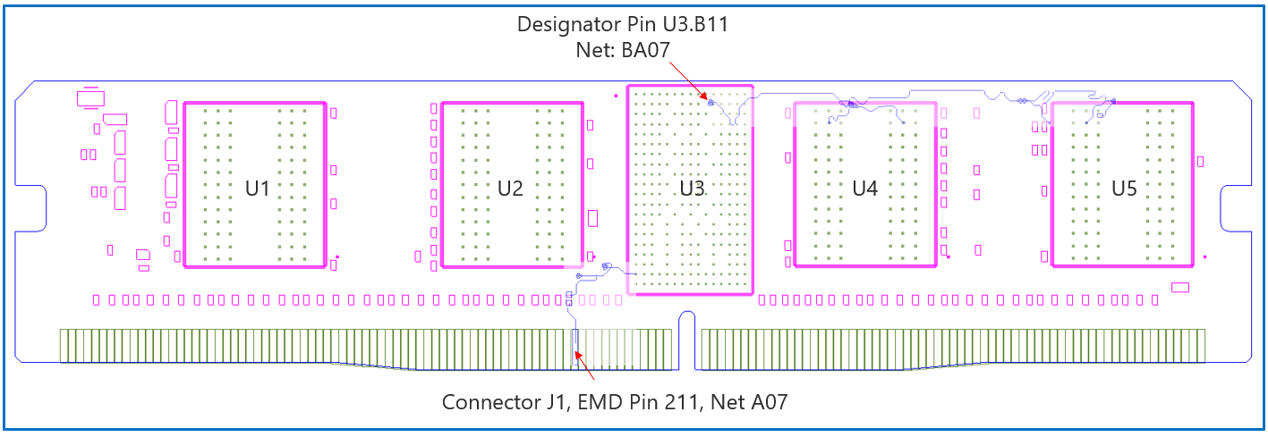
Figure X

Figure Y, a zoomed in area of Figure X, shows an example of an extended net. The extended net A07 can be modeled two ways:
- One EMD Model defining only terminals for EMD Pin 211 and Designator Pin U3.W1. The EMD Model contains the complete signal path of net A07, the series resistor R123, and net A07r.
- One EMD Model or multiple EMD Models contained with an EMD Set that include terminals for EMD Pin 211 and Designator Pin U3.W1 and two terminals for the pins of the series resistor. The resistor would be assigned a designator (R123) referencing an IBIS component.

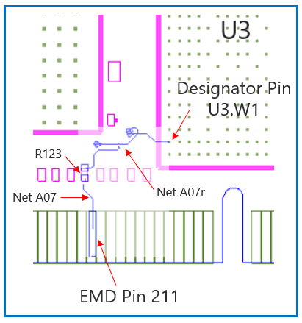
Figure Y

Figure Z, a zoomed in area of Figure X, shows an example of an internal net. The post-register net BA07 connects from the register’s Designator Pin U3.B11 to the DDR4 DRAMs’ Designator Pins U4.M8, U5.M8, U7.M8, and U8.M8 as well as to one Designator Pin of the termination resistor RN13. RN13 terminates the signal to the VTT rail.

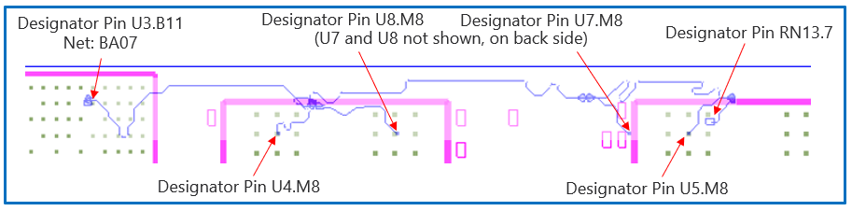
Figure Z

Example Syntax

| EMD Syntax Example 1 (Embedded Resistors)
| Using DDR4 RDIMM Example

[Begin EMD] DDR4_RDIMM
[Number of EMD Pins] 4
[EMD Pin List] signal_name signal_type bus_label
203 VSS GND
211 A07
212 VDD POWER VDD1
223 VTT POWER
[End EMD Pin List]

[EMD Parts]
DDR4_Reg_253b register.ibs DDR4_Register
DDR4_x8_78b dram.ibs DDR4_8Gb_x8
[End EMD Parts]

[EMD Designator List]
U3 DDR4_Reg_253b
U4 DDR4_x8_78b
U5 DDR4_x8_78b
U7 DDR4_x8_78b
U8 DDR4_x8_78b
[End EMD Designator List]

[Designator Pin List] signal_name signal_type bus_label
U3.B9 VDD POWER VDD1
U3.B11 BA07
U3.B12 VSS GND
U3.V3 VDD POWER VDD1
U3.W1 A07
U3.W3 VSS GND
|
U4.K9 VSS GND
U4.M8 BA07
U4.N9 VDD POWER VDD1
|
U5.K9 VSS GND
U5.M8 BA07
U5.N9 VDD POWER VDD1
|
U7.K9 VSS GND
U7.M8 BA07
U7.N9 VDD POWER VDD1
|
U8.K9 VSS GND
U8.M8 BA07
U8.N9 VDD POWER VDD1
[End Designator Pin List]

[Voltage List]
VDD 1.200 1.140 1.260
VSS 0.000 0.000 0.000
VTT 0.600 0.570 0.630
[End Voltage List]

[EMD Group] Just_One
Addr_07 NA
[End EMD Group]

[End EMD]

[EMD Set] Addr_07

[EMD Model] A07
File_IBIS-ISS A07.iss A07
Number_of_terminals = 6
1 Pin_I/O pin_name 211
2 Pin_I/O pin_name U3.W1
3 Pin_Rail bus_label VDD1
4 Pin_Rail signal_name VSS
5 Pin_Rail bus_label U3.VDD1
6 Pin_Rail bus_label U3.VSS
[End EMD Model]

[EMD Model] BA07
File_IBIS-ISS A07.iss BA07
Number_of_terminals = 16
1 Pin_I/O pin_name U3.B11
2 Pin_Rail bus_label U3.VDD1
3 Pin_Rail signal_name U3.VSS
4 Pin_I/O pin_name U4.M8
5 Pin_Rail bus_label U4.VDD1
6 Pin_Rail signal_name U4.VSS
7 Pin_I/O pin_name U5.M8
8 Pin_Rail bus_label U5.VDD1
9 Pin_Rail signal_name U5.VSS
10 Pin_I/O pin_name U7.M8
11 Pin_Rail bus_label U7.VDD1
12 Pin_Rail signal_name U7.VSS
13 Pin_I/O pin_name U8.M8
14 Pin_Rail bus_label U8.VDD1
15 Pin_Rail signal_name U8.VSS
17 Pin_Rail bus_label VDD1
18 Pin_Rail signal_name VTT
19 Pin_Rail signal_name VSS
[End EMD Model]

[End EMD Set]

| EMD Syntax Example 2 (External Resistors)
| Using DDR4 RDIMM Example

[Begin EMD] DDR4_RDIMM
[Number of EMD Pins] 4
[EMD Pin List] signal_name signal_type bus_label
203 VSS GND
211 A07
212 VDD POWER VDD1
223 VTT POWER
[End EMD Pin List]

[EMD Parts]
DDR4_Reg_253b register.ibs DDR4_Register
DDR4_x8_78b dram.ibs DDR4_8Gb_x8
510-500874 resistors.ibs RES_22OHM
510-501618 resistors.ibs RPACK4_33OHM
[End EMD Parts]

[EMD Designator List]
U3 DDR4_Reg_253b
U4 DDR4_x8_78b
U5 DDR4_x8_78b
U7 DDR4_x8_78b
U8 DDR4_x8_78b
R123 510-500874
RN13 510-501618
[End EMD Designator List]

[Designator Pin List] signal_name signal_type bus_label
U3.B9 VDD POWER VDD1
U3.B11 BA07
U3.B12 VSS GND
U3.V3 VDD POWER VDD1
U3.W1 A07
U3.W3 VSS GND
|
U4.K9 VSS GND
U4.M8 BA07
U4.N9 VDD POWER VDD1
|
U5.K9 VSS GND
U5.M8 BA07
U5.N9 VDD POWER VDD1
|
U7.K9 VSS GND
U7.M8 BA07
U7.N9 VDD POWER VDD1
|
U8.K9 VSS GND
U8.M8 BA07
U8.N9 VDD POWER VDD1
|
R123.1 A07
R123.2 A07
RN13.2 VTT POWER
RN13.7 BA07
[End Designator Pin List]

[Voltage List]
VDD 1.200 1.140 1.260
VSS 0.000 0.000 0.000
VTT 0.600 0.570 0.630
[End Voltage List]

[EMD Group] Just_One
Addr_07 NA
[End EMD Group]

[End EMD]

[EMD Set] Addr_07

[EMD Model] A07
File_IBIS-ISS A07.iss A07
Number_of_terminals = 8
1 Pin_I/O pin_name 211
2 Pin_I/O pin_name R123.1
3 Pin_I/O pin_name R123.2
4 Pin_I/O pin_name U3.W1
5 Pin_Rail bus_label VDD1
6 Pin_Rail signal_name VSS
7 Pin_Rail bus_label U3.VDD1
8 Pin_Rail signal_name U3.VSS
[End EMD Model]

[EMD Model] BA07
File_IBIS-ISS A07.iss BA07
Number_of_terminals = 16
1 Pin_I/O pin_name U3.B11
2 Pin_Rail bus_label U3.VDD1
3 Pin_Rail signal_name U3.VSS
4 Pin_I/O pin_name U4.M8
5 Pin_Rail bus_label U4.VDD1
6 Pin_Rail signal_name U4.VSS
7 Pin_I/O pin_name U5.M8
8 Pin_Rail bus_label U5.VDD1
9 Pin_Rail signal_name U5.VSS
10 Pin_I/O pin_name U7.M8
11 Pin_Rail bus_label U7.VDD1
12 Pin_Rail signal_name U7.VSS
13 Pin_I/O pin_name U8.M8
14 Pin_Rail bus_label U8.VDD1
15 Pin_Rail signal_name U8.VSS
16 Pin_I/O pin_name RN13.7
17 Pin_Rail bus_label VDD1
18 Pin_Rail pin_name RN13.VTT
19 Pin_Rail signal_name VSS
[End EMD Model]

[End EMD Set]

| EMD Syntax Example 3 (External Resistors, Separate A07, A07R, and POWER Models)
| Using DDR4 RDIMM Example
|
[Begin EMD] DDR4_RDIMM
[Number of EMD Pins] 4
[EMD Pin List] signal_name signal_type bus_label
203 VSS GND
211 A07
212 VDD POWER VDD1
223 VTT POWER
[End EMD Pin List]

[EMD Parts]
DDR4_Reg_253b register.ibs DDR4_Register
DDR4_x8_78b dram.ibs DDR4_8Gb_x8
510-500874 resistors.ibs RES_22OHM
510-501618 resistors.ibs RPACK4_33OHM
[End EMD Parts]

[EMD Designator List]
U3 DDR4_Reg_253b
U4 DDR4_x8_78b
U5 DDR4_x8_78b
U7 DDR4_x8_78b
U8 DDR4_x8_78b
R123 510-500874
RN13 510-501618
[End EMD Designator List]

[Designator Pin List] signal_name signal_type bus_label
U3.B9 VDD POWER VDD1
U3.B11 BA07
U3.B12 VSS GND
U3.V3 VDD POWER VDD1
U3.W1 A07
U3.W3 VSS GND
U4.K9 VSS GND
U4.M8 BA07
U4.N9 VDD POWER VDD1
U5.K9 VSS GND
U5.M8 BA07
U5.N9 VDD POWER VDD1
U7.K9 VSS GND
U7.M8 BA07
U7.N9 VDD POWER VDD1
U8.K9 VSS GND
U8.M8 BA07
U8.N9 VDD POWER VDD1
R123.1 A07
R123.2 A07
RN13.2 VTT POWER
RN13.7 BA07
[End Designator Pin List]

[Voltage List]
VDD 1.200 1.140 1.260
VSS 0.000 0.000 0.000
VTT 0.600 0.570 0.630
[End Voltage List]

[EMD Group] Just_One
Addr_07 NA
RIGHT_SIDE_POWER NA
[End EMD Group]

[End EMD]

[EMD Set] Addr_07
[EMD Model] A07
File_IBIS-ISS A07.iss A07
Number_of_terminals = 3
1 Pin_I/O pin_name 211
2 Pin_I/O pin_name R123.1
3 Pin_Rail signal_name VSS
[End EMD Model]
|
[EMD Model] A07R
File_IBIS-ISS A07.iss A07R
Number_of_terminals = 3
1 Pin_I/O pin_name R123.2
2 Pin_I/O pin_name U3.W1
3 Pin_Rail signal_name VSS
[End EMD Model]
|
[EMD Model] BA07
File_IBIS-ISS A07.iss BA07
Number_of_terminals = 16
1 Pin_I/O pin_name U3.B11
3 Pin_Rail signal_name U3.VSS
4 Pin_I/O pin_name U4.M8
6 Pin_Rail signal_name U4.VSS
7 Pin_I/O pin_name U5.M8
9 Pin_Rail signal_name U5.VSS
10 Pin_I/O pin_name U7.M8
12 Pin_Rail signal_name U7.VSS
13 Pin_I/O pin_name U8.M8
15 Pin_Rail signal_name U8.VSS
16 Pin_I/O pin_name RN13.7
18 Pin_Rail pin_name RN13.VTT
19 Pin_Rail signal_name VSS
[End EMD Model]
[End EMD Set]

[EMD Set] RIGHT_SIDE_POWER
[EMD Model] RIGHT_SIDE_VDD1_VTT_VSS
File_IBIS-ISS rdimm_power.iss RIGHT_SIDE_VDD1_VTT_VSS
Number_of_terminals = 8
1 Pin_Rail bus_label VDD1
2 Pin_Rail signal_name VSS
3 Pin_Rail signal_name VTT
4 Pin_Rail bus_label U3.VDD1
5 Pin_Rail signal_name U3.VSS
6 Pin_Rail bus_label U4.VDD1
7 Pin_Rail signal_name U4.VSS
8 Pin_Rail bus_label U5.VDD1
9 Pin_Rail signal_name U5.VSS
10 Pin_Rail bus_label U7.VDD1
11 Pin_Rail signal_name U7.VSS
12 Pin_Rail bus_label U8.VDD1
13 Pin_Rail signal_name U8.VSS
14 Pin_Rail signal_name RN13.VTT
[End EMD Model]
[End EMD Set]

