BUFFER ISSUE RESOLUTION DOCUMENT (BIRD)

BIRD NUMBER: 198
ISSUE TITLE: Keyword additions for On Die PDN (Power Distribution Network) Modeling
REQUESTOR: Kazuki Murata; Ricoh Co., Ltd.;
Miyoko Goto; Ricoh Co., Ltd.;
Kazuyuki Sakata; Renesas Electronics Corporation;
Kazunori Yamada; Renesas Electronics Corporation;
Kouji Ichikawa; Denso Corporation;
Atsushi Tomishima; Toshiba Electronic Devices & Storage Corporation;
Takashi Hasegawa; Sony LSI Design Inc.;
Koichi Seko, Panasonic Industrial Devices Systems and Technology Co., Ltd.;
Toshiki Kanamoto; Hirosaki University
Megumi Ono; Socionext Inc.
DATE SUBMITTED: March 11, 2019
DATE REVISED:
DATE ACCEPTED:

DEFINITION OF THE ISSUE:
To resolve the power-supply noise issue, especially high frequency range, on die decap should be taken account into the simulation. With current IBIS versions, “On Die PDN” can be defined by using the keyword [Series Pin Mapping] and “Model_type Series”.
However, this method seems not to be widely recognized, because the keyword [Series Pin Mapping] and “Model_type Series” don’t make imagine to describe the on die PDNmodel. To ease usage of “On Die PDN” in the IBIS model, this BIRD proposes to add the new keywords [PDN Model Mapping], “Model_type PDN”, [C pdn], [R pdn], [R leak], [C pdn corner], [R pdn corner] and [R leak corner] for PDN model only.
SOLUTION REQUIREMENTS:
The IBIS specification must meet these requirements:
Table 1: Solution Requirements
Requirement | Notes
- A new keyword is defined under [Component]:
[PDN Model Mapping]
- A new sub parameter is defined under [Model]: “Model_type PDN”
- PDN paths can be defined under [Model] with:[C pdn], [R pdn], [R leak] , [C pdn corner], [R pdn corner] and [R leak corner]

SUMMARY OF PROPOSED CHANGES:
For review purposes, the proposed changes are summarized as follows:
Table 2: IBIS Keywords, Subparameters, AMI Reserved_Parameters, and AMI functions Affected
Specification Item | New/Modified/Other | Notes
A new keyword is defined under [Component]:  [PDN Model Mapping] | New
A new sub parameter is defined under [Model]: “Model_type PDN” | New
PDN paths can be defined under [Model] with:[C pdn], [R pdn], [R leak], [C pdn corner], [R pdn corner] and [R leak corner] | New

PROPOSED CHANGES:
All page numbers refer to the PDF version of Third public of IBIS Version 7.0.
- In IBIS version 7.0, insert the [PDN Pin Mapping] keyword after [Series Pin Mapping] keyword on Page.44.
Keyword: [PDN Model Mapping]
Required: No
Description: Used to associate power and ground pins joined by a on die pdn model.
Sub-Params: pin_2, model_name,
Usage Rules: Enter only power and ground pins pairs. The first column, [PDN Model Mapping], contains the power and gound pin for which on die PDN. The second column, pin_2, contains the power pin connection of the on die PDN model. Each pin must match the pin names declared previously in the [Pin] section of the .ibs file. The third column, model_name, associates models of type PDN containing references to models of type PDN for the pair of pins in the first two columns. Each model_name must have a corresponding model name listed in a [Model] keyword below. The usage of reserved model names (POWER, GND, or NC) within the [PDN Model Mapping] keyword is not allowed.
Each line must contain three columns.

The column length limits are:
[PDN Model Mapping] 5 characters max
pin_2 5 characters max
model_name 40 characters max
Other Notes: Also, a pin name may appear on more than one entry under the [PDN Model Mapping] keyword. This allows for multiple and different on die PDN models to be placed between any arbitrary pin pair combinations.

Example:
[PDN Model Mapping]
C3 A1 OnChipDecap

- In IBIS version 7.0, insert the [PDN model Mapping] and PDN in [Model] keyword section, and add PDN rule into Table.1 on Page.47.

Keyword: [Model]
Required: Yes
Description: Used to define a model, and its attributes.
Sub-Params: Model_type, Polarity, Enable, Vinl, Vinh, C_comp, C_comp_pullup, C_comp_pulldown, C_comp_power_clamp, C_comp_gnd_clamp, Vmeas, Cref, Rref, Vref
Usage Rules: Each model type must begin with the keyword [Model]. The model name shall match one that is listed under a [Pin], [Model Selector] or [Series Pin Mapping] keyword and must not contain more than 40 characters. A .ibs file must contain enough [Model] keywords to cover all of the model names specified under the [Pin], [Model Selector] , [Series Pin Mapping] and [PDN Model Mapping] keywords, except for those model names that use reserved words (POWER, GND and NC).
Model_type must be one of the following:
Input, Output, I/O, 3-state, Open_drain, I/O_open_drain, Open_sink, I/O_open_sink, Open_source, I/O_open_source, Input_ECL, Output_ECL, I/O_ECL, 3-state_ECL, Terminator, Series, and Series_switch, PDN.
For true differential models documented under Section 6.3, Model_type must be one of the following:
Input_diff, Output_diff, I/O_diff, and 3-state_diff
Special usage rules for particular model types are provided in Table 1. Some definitions are included for clarification.

Table xx – Special Rules for Keyword [Model]
Model Type | Definition
PDN | This model type is for on die PDN models that can be described by [R pdn], [C pdn], [R leak], [R pdn corner], [C pdn corner] and [R leak corner] Keywords.

- In IBIS version 7.0, insert the [R pdn], [C pdn], [R leak] and [R pdn corner], [C pdn corner], [R leak corner] keywords after [R Series], [L Series], [C Series], [Rc Series] keywords on Page. 80.

Keywords: [R pdn], [C pdn], [R leak]
Required: Yes, if they exist in the design
Description: The data for these keywords allow the definition of PDN R, C paths.
Usage Rules: For each of these keywords, the three columns hold the typical, minimum, and maximum values. The three entries must be placed on a single line and must be separated by at least one whitespace character. All three columns are required for these keywords. However, data are only required in the typical column. If minimum and/or maximum values are not available, the reserved word “NA” must be used.
Other Notes:
The electrical circuit model for these keywords is shown in Figure xx.

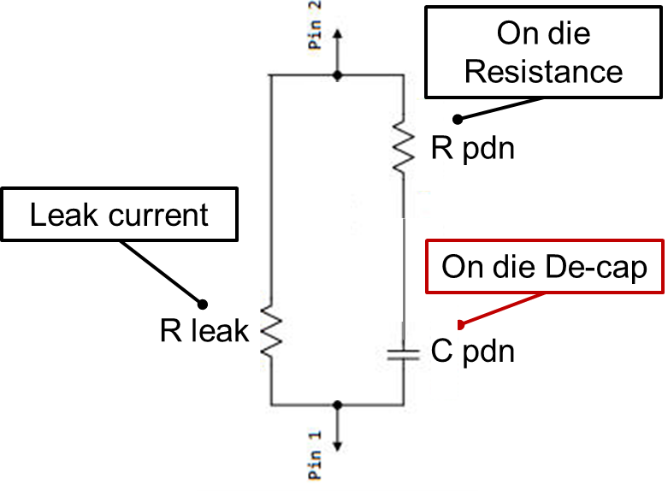
Figure XX Model_type PDN Topology

Example:
[Model] OnChipDecap
Model_type PDN

[C pdn] 3n 2.9n 3.1n
[R pdn] 0.1 0.1 0.1
[R leak] 200 200 200

Keywords: [R pdn corner], [C pdn corner], [R leak corner]
Required: No
Description: The data for these keywords allow the definition of PDN R, C paths.
Usage Rules: If [R pdn corner], [C pdn corner] and [R leak corner] are present, its entries take precedence over [R pdn], [C pdn] and [R leak], respectively. The entries are values associated with each of the typ/min/max corners rather than entered by magnitude as with the [R pdn], [C pdn] and [R leak] entries.
Other Notes: When [R pdn], [C pdn] and [R leak] values are obtained by extraction under the corner process, voltage, and temperature conditions, those entries are occasionally positioned with the maximum values under the min column and the minimum values under the max column. [R pdn], [C pdn] and [R leak] entries are entered into columns by numerical magnitude. The [* corner] entries override all other [R pdn], [C pdn] and [R leak] entries.
Example:
[Model] OnChipDecap
Model_type PDN
| variable typ min max
[C pdn corner] 3n 3.1n 2.9n
…

BACKGROUND INFORMATION/HISTORY:
This proposal has been discussed in JEITA LPB-SC Modeling WG.
Kazuki Murata (Ricoh) proposed in IBIS summit Japan 2017.
Kazuki Murata (Ricoh) presented in LPB Forum 2018.
Megumi Ono (Socionext) proposed in DesignCon 2019 IBIS summit.

