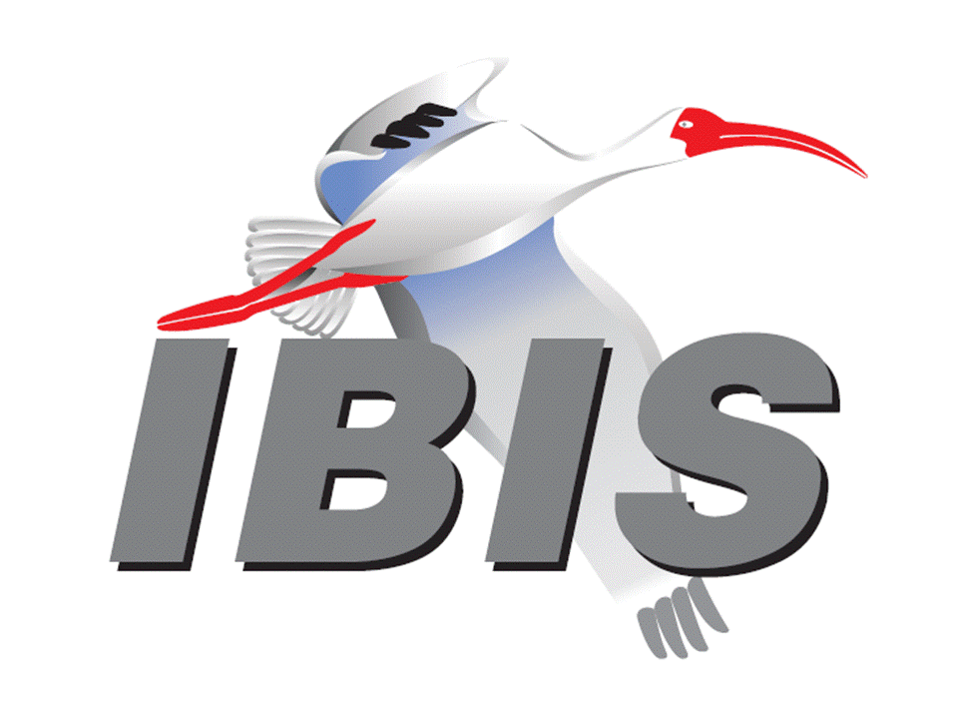
IBIS Open Forum Minutes

Meeting Date: July 22, 2016
Meeting Location: Teleconference

VOTING MEMBERS AND 2016 PARTICIPANTS
ANSYS Curtis Clark*, Toru Watanabe
Broadcom (Avago Technologies) Bob Miller
Cadence Design Systems Ken Willis, Brad Brim*
CST Stefan Paret
Ericsson Anders Ekholm, David Zhang, Zilwan Mahmod
GLOBALFOUNDRIES Steve Parker
Huawei Technologies (Jinjun Li)
IBM Adge Hawes, Luis Armenta
Infineon Technologies AG (Christian Sporrer)
Intel Corporation Hsinho Wu*, Mohammad Bapi, Michael Mirmak,
Masahi Shimanouchi, Todd Bermensolo, Zao Liu,
Gong Ouyang, Udy Shrivastava, Gianni Signorini,
Richard Mellitz
IO Methodology Lance Wang
Keysight Technologies Radek Biernacki*, Heidi Barnes, Jian Yang, Fangyi Rao, Stephen Slater, Pegah Alavi, Edwin Young
Maxim Integrated Products Yan Liang, Don Greer, Thinh Nguyen, Joe Engert,
Hock Seon, Ahmed Gendy*
Mentor Graphics Arpad Muranyi*, Vladimir Dmitriev-Zdorov, John Angulo,
Mikael Stahlberg
Micron Technology Randy Wolff*
Signal Integrity Software Mike LaBonte*, Walter Katz, Todd Westerhoff,
Richard Allred
Synopsys Ted Mido*, Kevin Li, Massimo Prando
Teraspeed Labs Bob Ross*
Xilinx (Raymond Anderson)
ZTE Corporation (Shunlin Zhu)
Zuken Michael Schaeder, Amir Wallrabenstein

OTHER PARTICIPANTS IN 2016
Cisco Systems Giuseppi Selli, Brian Baek
eASIC David Banas
Fujitsu Advanced Technologies Shogo Fujimori
Ghent University Paolo Manfredi
H3C Bin Cheng, Mao Jun
Hamburg University of Technology Jan Preibisch, David Dahl
Independent Carl Gabrielson
Institut Supérieur des Sciences Wael Dghais
Appliquées et de Technologie de
Sousse
JEITA Yosuke Kanamaru
John Baprawski, Inc. John Baprawski
KEI Systems Shinichi Maeda
Lattice Semiconductor Dinh Tran, Maryam Shahbazi
Leading Edge Pietro Vergine
MathWorks Mike Mulligan, Corey Mathis
Monsoon Solutions Nathan Hirsch
Northrup Grumman Alex Golian
NXP Jon Burnett
Politecnico di Torino Claudio Siviero, Stefano Grivet-Talocia,
Igor Simone Stievano
Rambus John Yan
Raytheon Joseph Aday
SAE International (Logen Johnson)
SILABTECH Biman Chattopadhyary
Signal Metrics Ron Olisar
SiGuys Donald Telian
Sony Corporation Hiroaki Ammo
Sony LSI Design Takashi Hasegawa
SPISim Wei-hsing Huang
STMicroelectronics Fabio Brina, Olivier Bayet
Technoprobe Alberto Berizzi, Lorenzo Bernasconi, Simona Cucchi
Université de Bretagne Occidentale Mihai Telescu

In the list above, attendees at the meeting are indicated by *. Principal members or other active members who have not attended are in parentheses. Participants who no longer are in the organization are in square brackets.

UPCOMING MEETINGS
The bridge numbers for future IBIS teleconferences are as follows:

Date Meeting Number Meeting Password
August 12, 2016 205 475 958 IBIS

For teleconference dial-in information, use the password at the following website:

https://ciscosales.webex.com/ciscosales/j.php?J=205475958

All teleconference meetings are 8:00 a.m. to 9:55 a.m. US Pacific Time. Meeting agendas are typically distributed seven days before each Open Forum. Minutes are typically distributed within seven days of the corresponding meeting. When calling into the meeting, follow the prompts to enter the meeting ID. For new, local international dial-in numbers, please reference the bridge numbers provided by Cisco Systems at the following link:

http://www.cisco.com/web/about/doing_business/conferencing/index.html

NOTE: "AR" = Action Required.

-------------------------------------------------------------------------------------------------------------------------------
INTRODUCTIONS AND MEETING QUORUM
Randy Wolff declared that a quorum was reached and the meeting could begin. Ahmed Gendy from Maxim was a new participant and introduced himself.

CALL FOR PATENTS
Mike LaBonte called for declaration of any patents or pending patents related to the IBIS 3.2, IBIS 4.2, IBIS 5.1, IBIS 6.1, Touchstone 2.0, IBIS-ISS 1.0 or ICM 1.1 specifications. No patents were declared.

REVIEW OF MINUTES AND ARS
Randy Wolff called for comments on the minutes of the July 1, 2016 IBIS Open Forum teleconference. He noted a correction from Bob Ross that the motion to un-table BIRD180 failed, not passed. Curtis Clark moved to approve the minutes with the noted change. Bob Ross seconded the motion. There were no objections.

Randy reviewed ARs from the previous meeting.

- Mike LaBonte to update email lists web page [AR].
Mike reported the AR as done.

- Bob Ross to finalize signed parser contract [AR].
Bob reported the AR as done.

ANNOUNCEMENTS, CALL FOR ADDITIONAL AGENDA ITEMS
None.

MEMBERSHIP STATUS AND TREASURER'S REPORT
Bob Ross reported that we have 21 members. We are waiting for a renewal, for which payment hasn’t been made. We have a total of $21,416 for 2016. Actual cash flow of $17,105 has been collected this year. National Instruments paid for a $2500 IBISCHK6 parser license.

WEBSITE ADMINISTRATION
Mike LaBonte reported that he created a Regional Forums category on the main web page with “China” as a sub-category. The IBIS China Regional Group page is an about page with essential information for the group including how to sign up for email discussion. There is a work archive that is empty currently. There are also meeting minutes linked.

Mike noted that the left side navigation is present on other pages in the site, but it is a static placement. Bob added that the minutes for the China regional group will likely be in Mandarin. Mike noted that he added in a new hook, with an English summary under the title that will appear for added help.

MAILING LIST ADMINISTRATION
Curtis Clark reported it has been quiet with some churn from company mergers causing some addresses to drop off the list.

LIBRARY UPDATE
No update.

INTERNATIONAL/EXTERNAL ACTIVITIES
- Conferences
The IEEE conference on Electrical Performance of Electronic Packages and Systems (EPEPS) is in San Diego, CA October 23-26, 2016. EPEPS sometimes includes specific IBIS content as well as general SI and PI content.

http://www.epeps.org

The IEEE conference on Electrical Design of Advanced Packaging and Systems (EDAPS) is in Honolulu, HI December 14-16, 2016. EDAPS covers SI and PI issues, although IBIS does not affiliate with it.

http://edaps2016.org/

- Press Update
None.

- Related standards
None.

SUMMIT PLANNING AND STATUS
- Asian IBIS Summit (Shanghai)
The meeting will take place November 11, 2016 at the Parkyard Hotel. Huawei Technologies is the primary sponsor and additional sponsors include Xpeedic Technology and ZTE Corporation.

- Asian IBIS Summit (Taipei)
The meeting will take place November 14, 2016. Mike LaBonte reported that he has been investigating two venues including the Courtyard Hotel and the Sherwood Hotel. He has negotiated with the Sherwood to reduce their original quote to only 5% larger than last year. Facilities at the Sherwood look better than the Courtyard. Bob Ross noted that we may consider the Courtyard next year if Intel has completed moves to the offices near there. Mike noted he will scout the area near the Courtyard. Xpeedic Technology is a sponsor.

- Asian IBIS Summit (Tokyo)
The meeting will take place November 18, 2016. Bob noted that the meeting will be a half day. JEITA may expand and hold a class on IBIS in the morning, hosted by JEITA’s IBIS promotion working group. JEITA and IBIS are sponsors.

- Other Summits
Bob noted that SPI 2017 will be in Baveno, Italy. If we hold an IBIS Summit meeting it will be May 10, 2017.

Bob noted that EPEPS 2017 will be in the San Jose area. We may hold a Summit there since the location is good for attendance.

Sponsorship opportunities for all upcoming IBIS summits are available, with sponsors receiving free mentions in the minutes, agenda, and other announcements. Contact the IBIS Board for further details.

QUALITY TASK GROUP
Mike LaBonte reported that the group is meeting on Tuesdays at 8:00 a.m. PT. The group is discussing IBISCHK development and enhancements.

The IBISCHK6 user guide work in progress can be reviewed at:

http://www.ibis.org/ibischk6/ibischk_6.1.1_UserGuide_wip1.pdf

The Quality Task Group checklist and other documentation can be found at:

http://www.ibis.org/quality_wip/

ADVANCED TECHNOLOGY MODELING TASK GROUP
Arpad Muranyi reported that the group is meeting regularly on Tuesdays at 12:00 p.m. PT. The group is discussing ground cleanup relative to the IBIS specification and the Interconnect task group’s discussions. Bob Ross added that the C_comp modeling proposal was also updated at the last meeting.

Task group material can be found at:

http://www.ibis.org/macromodel_wip/

INTERCONNECT TASK GROUP
Mike LaBonte reported that the group is meeting on Wednesdays at 8:00 a.m. PT. The group is making progress on the new Interconnect BIRD, which currently is at draft 37 with some contributions being compiled for a draft 38. One important topic has to do with interconnect model sets versus interconnect models, and hierarchy of the two is being discussed.

Task group material can be found at:

http://www.ibis.org/interconnect_wip/

EDITORIAL TASK GROUP
Mike LaBonte reported that the group is meeting on Fridays at 8:00 a.m. PT on weeks the Open Forum teleconference is not held. The main topic of discussion is ground referencing. Soon we will begin forming the 6.2 document with changes. Bob Ross added that we should only bring in approved, voted on BIRDs in the process. Other changes being discussed have not been vetted yet. Mike noted we’ve had a fair amount of discussion not focused on BIRDs, but we have a list of at least three BIRDs that need to be written. Bob added that the BIRDs are technical changes, so they go beyond the charter of the editorial committee to just work on editorial changes.

Task group material can be found at:

http://www.ibis.org/editorial_wip/

NEW ADMINISTRATIVE ISSUES
- Second revision of IBIS Policies and Procedures
Mike LaBonte reported that at the time of the last meeting, a draft had been floated with the board. Nothing has changed since the last meeting. He will contact the board for any further review to see if the P&P document is ready for public review [AR].

The document can be found at:

http://www.ibis.org/policies/

BIRD125.1: MAKE IBIS-ISS AVAILABLE FOR IBIS PACKAGE MODELING
Discussion was tabled.

BIRD128.2: ALLOW AMI_PARAMETERS_OUT TO PASS AMI_PARAMETERS_IN DATA ON CALLS TO AMI_GETWAVE
Discussion was tabled.

BIRD145.3: CASCADING IBIS I/O BUFFERS WITH [EXTERNAL CIRCUIT]S USING THE [MODEL CALL] KEYWORD
Discussion was tabled.

BIRD147: BACK-CHANNEL SUPPORT
Discussion was tabled.

BIRD158.3: AMI TOUCHSTONE ANALOG BUFFER MODELS
Discussion was tabled.

BIRD161.1: SUPPORTING INCOMPLETE AND BUFFER-ONLY [COMPONENT] DESCRIPTIONS
Discussion was tabled.

BIRD163: INSTANTIATING AND CONNECTING [EXTERNAL CIRCUIT] PACKAGE MODELS WITH [CIRCUIT CALL]
Discussion was tabled.

BIRD164: ALLOWING PACKAGE MODELS TO BE DEFINED IN [EXTERNAL CIRCUIT]
Discussion was tabled.

BIRD165: PARAMETER PASSING IMPROVEMENTS FOR [EXTERNAL CIRCUIT]S
Discussion was tabled.

BIRD166: RESOLVING PROBLEMS WITH REDRIVER INIT FLOW
Discussion was tabled.

BIRD180: REQUIRE UNIQUE PIN NAMES IN [PIN]
Discussion was tabled.

IBISCHK6 PARSER AND BUG STATUS
Bob Ross reported that the contract has been signed for IBISCHK 6.1.2 development. The delivery date is somewhere in the middle of August.

BUG180 was discovered by Mike LaBonte. There is a List_Tip problem in Reserved_Parameters. Adding in a List_Tip for a Modulation or PAM4_Mapping reserved parameter causes an error. These were the first reserved parameters to allow a List format. Mike asked if this bug could be fixed in the upcoming parser release. Bob thought this should be ok.

Radek Biernacki moved to classify BUG180 as moderate severity, medium priority and open status. Curtis Clark seconded the motion. There were no objections.

Mike LaBonte will update the bug web page [AR].

NEW TECHNICAL ISSUES
None.

NEXT MEETING
The next IBIS Open Forum teleconference meeting will be held August 12, 2016. The following IBIS Open Forum teleconference meeting will tentatively be held September 2, 2016.

Bob Ross moved to adjourn. Curtis Clark seconded the motion.

========================================================================
NOTES

IBIS CHAIR: Mike LaBonte
mlabonte@sisoft.com
IBIS-AMI Modeling Specialist, Signal Integrity Software
6 Clock Tower Place, Suite 250
Maynard, MA 01754

VICE CHAIR: Lance Wang (978) 633-3388
lwang@iometh.com
President/CEO, IO Methodology, Inc.
PO Box 2099
Acton, MA 01720

SECRETARY: Randy Wolff (208) 363-1764
rrwolff@micron.com
Principal Engineer, Silicon SI Group Lead, Micron Technology, Inc.
8000 S. Federal Way
P.O. Box 6, Mail Stop: 01-711
Boise, ID 83707-0006

TREASURER: Bob Ross (503) 246-8048
bob@teraspeedlabs.com
Engineer, Teraspeed Labs
10238 SW Lancaster Road
Portland, OR 97219

LIBRARIAN: Anders Ekholm (46) 10 714 27 58, Fax: (46) 8 757 23 40
ibis-librarian@ibis.org
Digital Modules Design, PDU Base Stations, Ericsson AB
BU Network
Färögatan 6
164 80 Stockholm, Sweden

WEBMASTER: Mike LaBonte
mlabonte@sisoft.com
IBIS-AMI Modeling Specialist, Signal Integrity Software
6 Clock Tower Place, Suite 250
Maynard, MA 01754

POSTMASTER: Curtis Clark
curtis.clark@ansys.com
ANSYS, Inc.
150 Baker Ave Ext
Concord, MA 01742

This meeting was conducted in accordance with ANSI guidance.

All inquiries may be sent to info@ibis.org. Examples of inquiries are:
- To obtain general information about IBIS.
- To ask specific questions for individual response.
- To subscribe to the official ibis@freelists.org and/or ibis-users@freelists.org email lists (formerly ibis@eda.org and ibis-users@eda.org).
- To subscribe to one of the task group email lists: ibis-macro@freelists.org, ibis-interconn@freelists.org, or ibis-quality@freelists.org.
- To inquire about joining the IBIS Open Forum as a voting Member.
- To purchase a license for the IBIS parser source code.
- To report bugs or request enhancements to the free software tools: ibischk6, tschk2, icmchk1, s2ibis, s2ibis2 and s2iplt.
The BUG Report Form for ibischk resides along with reported BUGs at:

http://www.ibis.org/bugs/ibischk/
http://www.ibis.org/ bugs/ibischk/bugform.txt

The BUG Report Form for tschk2 resides along with reported BUGs at:

http://www.ibis.org/bugs/tschk/
http://www.ibis.org/bugs/tschk/bugform.txt

The BUG Report Form for icmchk resides along with reported BUGs at:

http://www.ibis.org/bugs/icmchk/
http://www.ibis.org/bugs/icmchk/icm_bugform.txt

To report s2ibis, s2ibis2 and s2iplt bugs, use the Bug Report Forms which reside at:

http://www.ibis.org/bugs/s2ibis/bugs2i.txt
http://www.ibis.org/bugs/s2ibis2/bugs2i2.txt
http://www.ibis.org/bugs/s2iplt/bugsplt.txt

Information on IBIS technical contents, IBIS participants and actual IBIS models are available on the IBIS Home page:

http://www.ibis.org/

Check the IBIS file directory on ibis.org for more information on previous discussions and results:

http://www.ibis.org/directory.html

Other trademarks, brands and names are the property of their respective owners.
SAE STANDARDS BALLOT VOTING STATUS
Organization | Interest Category | Standards Ballot Voting Status | May 20, 2016 | June 10, 2016 | July 1, 2016 | July 22, 2016
ANSYS | User | Active | X | X | X | X
Broadcom Ltd. | Producer | Inactive | - | - | - | -
Cadence Design Systems | User | Active | X | X | X | X
CST | User | Inactive | - | - | - | -
Ericsson | Producer | Inactive | - | - | - | -
GLOBALFOUNDRIES | Producer | Active | - | X | X | -
Huawei Technologies | Producer | Inactive | - | - | - | -
Infineon Technologies AG | Producer | Inactive | - | - | - | -
IBM | Producer | Inactive | - | X | - | -
Intel Corp. | Producer | Active | X | X | X | X
IO Methodology | User | Inactive | X | X | - | -
Keysight Technologies | User | Active | X | X | X | X
Maxim Integrated Products | Producer | Inactive | - | - | - | X
Mentor Graphics | User | Active | X | X | X | X
Micron Technology | Producer | Active | X | X | X | X
Signal Integrity Software | User | Active | - | X | X | X
Synopsys | User | Active | X | X | - | X
Teraspeed Labs | General Interest | Active | X | X | X | X
Xilinx | Producer | Inactive | - | - | - | -
ZTE | User | Inactive | - | - | - | -
Zuken | User | Inactive | - | - | - | -

Criteria for SAE member in good standing:
- Must attend two consecutive meetings to establish voting membership
- Membership dues current
- Must not miss two consecutive meetings
Interest categories associated with SAE standards ballot voting are:
- Users - members that utilize electronic equipment to provide services to an end user.
- Producers - members that supply electronic equipment.
- General Interest - members are neither producers nor users. This category includes, but is not limited to, government, regulatory agencies (state and federal), researchers, other organizations and associations, and/or consumers.

