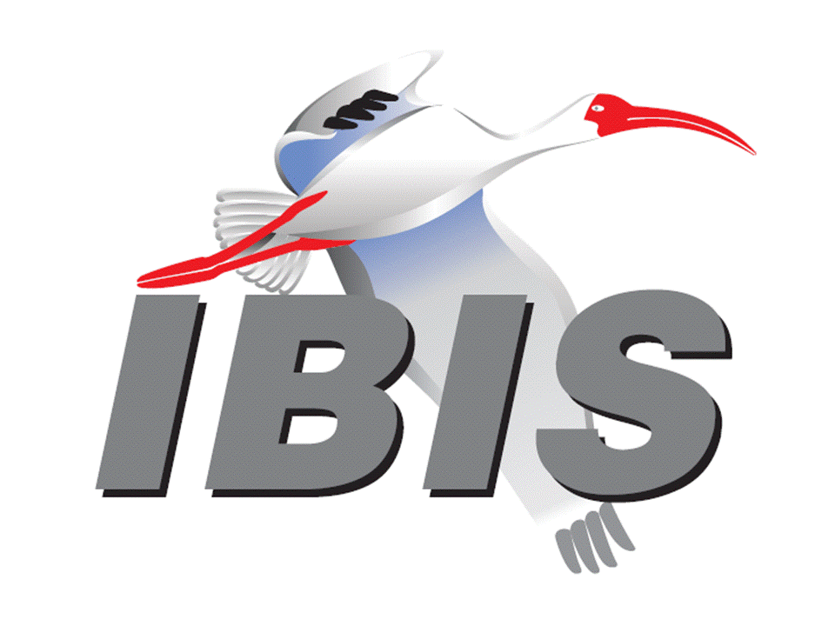

IBIS Open Forum Minutes

Meeting Date: September 21, 2018
Meeting Location: Teleconference

VOTING MEMBERS AND 2018 PARTICIPANTS
ANSYS Curtis Clark*
Applied Simulation Technology (Fred Balistreri)
Broadcom (Yunong Gan)
Cadence Design Systems Brad Brim, Ken Willis, Ambrish Varma, Zhen Mu
Cisco Systems Stephen Scearce, Cassie Yan, Baosh Xu
CST Stefan Paret
Ericsson Anders Ekholm, Zilwan Mahmod, Guohua Wang
GLOBALFOUNDRIES Steve Parker*
Huawei Technologies (Hang (Paul) Yan)
IBM Greg Edlund, Luis Armenta, Hubert Harrer
Infineon Technologies AG (Christian Sporrer)
Intel Corporation Hsinho Wu*, Michael Mirmak*, Nilesh Dattani
Fernando Mendoza Hernandez, Varun Gupta
Subas Bastola, Hansel Dsilva, Gianni Signorini
IO Methodology Lance Wang*
Keysight Technologies Radek Biernacki*, Ming Yan, Heidi Barnes
Pegah Alavi
Maxim Integrated Joe Engert, Yan Liang
Mentor, A Siemens Business Arpad Muranyi*, Weston Beal, Raj Raghuram
Carlo Bleu, Mikael Stahlberg, Yasushi Kondou
Vladimir Dmitriev-Zdorov, Nitin Bhagwath
Micron Technology Randy Wolff*, Justin Butterfield
NXP (John Burnett)
Raytheon Joseph Aday
SiSoft Mike LaBonte*, Walter Katz*, Todd Westerhoff
Synopsys Ted Mido, Adrien Auge, Scott Wedge
Teraspeed Labs Bob Ross*
Xilinx Ravindra Gali
ZTE Corporation (Shunlin Zhu)
Zuken Michael Schaeder, Takayuki Shiratori

OTHER PARTICIPANTS IN 2018
Google Zhiping Yang
Haskware David Banas
John Baprawski, Inc. John Baprawski
KEI Systems Shinichi Maeda
Lattice Semiconductor Dinh Tran, Maryam Shahbazi
OmniVision Sirius Tsang
Politecnico di Milano Flavia Grassi, Xinglong Wu
Politecnico di Torino Tommaso Bradde, Marco De Stefano, Paulo Manfredi
Riccardo Trinchero, Stefano Grivet-Talocia
Qualcomm Kevin Roselle, Tim Michalka
Ricoh Kazuki Murata
RITA Electronics Ltd. Kenichi Higashiura, Hiroyuki Motoki
SAE ITC (Jose Godoy)
Signal Metrics Ron Olisar
Socionext Megumi Ono
SPISim Wei-hsing Huang
Stanford University Tom Lee
STMicroelectronics Aurora Sanna, Olivier Bayet
Toshiba Yasuki Torigoshi, Yoshinori Fukuba
Université de Bretagne Occidentale Mihai Telescu, Charles Canaff
University of Illinois José Schutt-Aine
University of Siegen Elmar Griese
University of Technology Hamburg Torben Wendt
In the list above, attendees at the meeting are indicated by *. Principal members or other active members who have not attended are in parentheses. Participants who no longer are in the organization are in square brackets.

UPCOMING MEETINGS
The bridge numbers for future IBIS teleconferences are as follows:

Date Meeting Number Meeting Password
October 12, 2018 624 227 121 IBISfriday11

For teleconference dial-in information, use the password at the following website:

http://tinyurl.com/y7yt7buz

All teleconference meetings are 8:00 a.m. to 9:55 a.m. US Pacific Time. Meeting agendas are typically distributed seven days before each Open Forum. Minutes are typically distributed within seven days of the corresponding meeting.

NOTE: "AR" = Action Required.

-------------------------------------------------------------------------------------------------------------------------------
INTRODUCTIONS AND MEETING QUORUM
Randy Wolff declared that a quorum was reached and the meeting could begin.

CALL FOR PATENTS
Mike LaBonte called for declaration of any patents or pending patents related to the IBIS 3.2, IBIS 4.2, IBIS 5.1, IBIS 6.1, Touchstone 2.0, IBIS-ISS 1.0 or ICM 1.1 specifications. No patents were declared.

REVIEW OF MINUTES AND ARS
Mike LaBonte called for comments on the minutes of the August 31, 2018 IBIS Open Forum teleconference. Curtis Clark moved to approve the minutes. Bob Ross seconded the motion. There were no objections.

Mike reviewed ARs from the previous meeting.

- Mike LaBonte to update the website to reflect BIRD195.1 as approved [AR].
Mike reported this as done.

ANNOUNCEMENTS, CALL FOR ADDITIONAL AGENDA ITEMS
None.

MEMBERSHIP STATUS AND TREASURER'S REPORT
Bob Ross reported that we have 25 members. There is $23,209 in our account accumulated for 2018. There is some activity pending related to sponsorships.

WEBSITE ADMINISTRATION
Mike LaBonte reported that normal maintenance has happened. He noted that there is a model review service. The webpage specifically lists support for reviewing IBIS-AMI models. Bob Ross commented there is little activity, and he doesn’t mind opening the service to review of non-IBIS-AMI models. Another option is to close down the service completely.

MAILING LIST ADMINISTRATION
Curtis Clark reported everything is going smoothly. He thinks the issue with Arpad Muranyi getting bounce backs from a particular user on the ATM reflector has been resolved. Curtis ended up unsubscribing the user after they did not respond to emails asking if they wanted to stay on the list.

LIBRARY UPDATE
No update.

INTERNATIONAL/EXTERNAL ACTIVITIES
- Conferences
EPEPS – The 27th IEEE Conference on Electrical Performance of Electronic Packaging and Systems will be held in San Jose, CA on October 14-17, 2018. More information is available at:

http://www.epeps.org/

EDI CON – Electronic Design Innovation Conference & Exhibition will be held in Santa Clara, CA on October 17-18, 2018. More information is available at:

http://www.ediconusa.com

- Press Update
None.

- Related standards
IEC 63055/IEEE 2401, JEITA “LPB”
Michael Mirmak reported that the 2401 group met on Tuesday to review Draft 1 of the 2401 update. There were about 20-25 comments to review. The JEITA group taking up the document change process has a few policy issues they need to settle. IBIS was well represented. There were questions about if LPB will support particular versions of IBIS and Touchstone, as well as the level of support for S-parameters and other network parameter formats. 2401 is aware of some of the parser changes ongoing with IBIS. There will be a Draft 2 open for comment sometime after Draft 1 is updated in October. Mike LaBonte asked about access to the draft, as he doesn’t have it currently. Michael Mirmak noted that Jonathan Goldberg could answer questions about IBIS participation and access to the draft documents. Comments on the draft would be very valuable.

Bob Ross asked if Michael was a member of 2401 as a representative of Intel. Michael confirmed this is correct. Bob asked if there are any other attendees that are knowledgeable about IBIS. Michael noted there is a strong EDA representation. Outside of JEITA participants, he doesn’t recognize very many of the other participants, so he doesn’t know their exposure to IBIS or interconnect modeling.

SUMMIT PLANNING AND STATUS
- Asian IBIS Summit (Tokyo)
An IBIS Summit will be held at the Akihabara UDX building from 12:30 p.m. to 5:00 p.m. on November 12, 2018. Bob Ross noted JEITA is handling the Summit arrangements. There is a separate JEITA event in the morning which is open but conducted in Japanese. The topic is S-parameters. We will find out later on who the sponsors are from JEITA.

- Asian IBIS Summit (Shanghai)
An IBIS Summit will be held at the Parkyard Hotel Shanghai from 8:30 a.m. to 5:00 p.m. on November 14, 2018. Huawei Technologies is the primary sponsor, and ZTE and Synopsys are additional sponsors. Bob noted we are expecting more sponsor commitments. One presentation is scheduled so far. A link to the Chinese version of the Summit announcement needs to be added to the IBIS website.

- Asian IBIS Summit (Taipei)
An IBIS Summit will be held at the Sherwood Hotel from 9:00 a.m. to 4:30 p.m. on November 16, 2018. Cadence Design Systems, KairosTech Innovation (SPISim), and Synopsys are sponsors.

Announcements for the three Summits will start going out next week. Mike LaBonte will update the IBIS events page with links to the Chinese and Japanese language Summit announcements [AR].

- DesignCon 2019 IBIS Summit
Mike noted he has contacted UBM to begin negotiations for the barter agreement.

Sponsorship opportunities for all upcoming IBIS summits are available, with sponsors receiving free mentions in the minutes, agenda, and other announcements. Contact the IBIS Board for further details.

QUALITY TASK GROUP
Mike LaBonte reported that the group is meeting on Tuesdays at 8:00 a.m. PT. The focus is about IBISCHK. They have considered a new bug recently. They are making preparations for an IBISCHK6.1.5 and an IBISCHK7 parser.

The Quality task group checklist and other documentation can be found at:

http://www.ibis.org/quality_wip/

ADVANCED TECHNOLOGY MODELING TASK GROUP
Arpad Muranyi reported that the group is meeting regularly on Tuesdays at 12:00 p.m. PT. The group recently discussed a question from the Editorial task group related to file naming rules. Arpad submitted a BIRD196 draft for discussion next Tuesday. He hopes to submit it to the IBIS Open Forum next week for review.

Task group material can be found at:

http://www.ibis.org/macromodel_wip/

INTERCONNECT TASK GROUP
Michael Mirmak reported that the group usually meets at 8:00 a.m. PT on Wednesdays. The group remains suspended.

Task group material can be found at:

http://www.ibis.org/interconnect_wip/

EDITORIAL TASK GROUP
Michael Mirmak reported that the group is meeting at 8:00 a.m. PT on Wednesdays and on Fridays when there is no Open Forum teleconference. He reported that they are trying to move through all the new BIRDs proposed for IBIS 7.0. They looked at the details of the issues later captured in BIRD196 written by Arpad Muranyi. There are more editorial passes for spelling and consistency to go through. They hope to have a draft for review by the Open Forum before the end of the year.

Task group material can be found at:

http://www.ibis.org/editorial_wip/

NEW ADMINISTRATIVE ISSUES
None.

BIRD166.4: RESOLVING PROBLEMS WITH REDRIVER INIT FLOW
Discussion was tabled.

BIRD181.1: I-V TABLE CLARIFICATIONS
Discussion was tabled.

BIRD190: CLARIFICATION FOR REDRIVER FLOW
Discussion was tabled.

IBISCHK PARSER AND BUG STATUS
Bob Ross noted a vote is pending to approve IBISCHK6.1.5 funding. There is a new possible bug related to a segmentation fault with respect to Linux only and .so files compiled with different versions of libraries. The bug fix is not obvious yet, so it is unclear if the bug can be slipped into the parser contract. Mike LaBonte commented that if anyone has seen any IBISCHK crashes, additional information might help. When IBISCHK runs on the .so files for both a TX and RX model, there is a crash occurring. The files load and simulate fine in tested simulators. The issue is related to loading both models for IBSCHK parsing, as the issue does not occur with a single model.

Bob moved to spend $1,000 to develop an IBISCHK6.1.5 parser update. Michael Mirmak seconded the motion. There were no objections.

The roll call vote tally was:

ANSYS – yes
GLOBALFOUNDRIES – yes
Infineon – yes (by email)
Intel – yes
IO Methodology – yes
Keysight – yes
Mentor – yes
Micron – yes
SiSoft – yes
Teraspeed Labs – yes

The roll call vote concluded with a vote tally of Yes – 10, No – 0, Abstain – 0. The vote passed.

Bob noted that the contract for the IBISCHK7.0 parser is in progress.

NEW TECHNICAL ISSUES
Arpad Muranyi asked if a vote could be tentatively scheduled for BIRD196 for the next IBIS Open Forum meeting. Bob Ross commented it would need to be submitted two weeks before the meeting. Arpad noted we usually only schedule a vote in the meeting after it is introduced for the next meeting. Mike added the BIRD would need to be sent to him to be announced in the next week.

Bob moved to schedule a vote on BIRD196 for the next meeting. He noted it is a minor clarification BIRD that should not be contentious. Radek Biernacki seconded the motion. There were no objections.

NEXT MEETING
The next IBIS Open Forum teleconference meeting will be held on October 12, 2018. A vote is scheduled on BIRD196. The following IBIS Open Forum teleconference meeting is tentatively scheduled on November 2, 2018.

Mike LaBonte thanked all the officers, task group chairs, and meeting minutes takers for their involvement in IBIS. Bob Ross and Michael Mirmak expressed their appreciation for Mike as well.

Bob moved to adjourn. Curtis Clark seconded the motion. The meeting adjourned.

========================================================================
NOTES

IBIS CHAIR: Mike LaBonte
mlabonte@sisoft.com
IBIS-AMI Modeling Specialist, SiSoft
6 Clock Tower Place, Suite 250
Maynard, MA 01754

VICE CHAIR: Lance Wang (978) 633-3388
lwang@iometh.com
President/CEO, IO Methodology, Inc.
PO Box 2099
Acton, MA 01720

SECRETARY: Randy Wolff (208) 363-1764
rrwolff@micron.com
Principal Engineer, Silicon SI Group Lead, Micron Technology, Inc.
8000 S. Federal Way
P.O. Box 6, Mail Stop: 01-711
Boise, ID 83707-0006

TREASURER: Bob Ross (503) 246-8048
bob@teraspeedlabs.com
Engineer, Teraspeed Labs
10238 SW Lancaster Road
Portland, OR 97219

LIBRARIAN: Anders Ekholm (46) 10 714 27 58, Fax: (46) 8 757 23 40
ibis-librarian@ibis.org
Digital Modules Design, PDU Base Stations, Ericsson AB
BU Network
Färögatan 6
164 80 Stockholm, Sweden

WEBMASTER: Mike LaBonte
mlabonte@sisoft.com
IBIS-AMI Modeling Specialist, SiSoft
6 Clock Tower Place, Suite 250
Maynard, MA 01754

POSTMASTER: Curtis Clark
curtis.clark@ansys.com
ANSYS, Inc.
150 Baker Ave Ext
Concord, MA 01742

This meeting was conducted in accordance with ANSI guidance.

All inquiries may be sent to info@ibis.org. Examples of inquiries are:
- To obtain general information about IBIS.
- To ask specific questions for individual response.
- To subscribe to the official ibis@freelists.org and/or ibis-users@freelists.org email lists (formerly ibis@eda.org and ibis-users@eda.org).
- To subscribe to one of the task group email lists: ibis-macro@freelists.org, ibis-interconn@freelists.org, or ibis-quality@freelists.org.
- To inquire about joining the IBIS Open Forum as a voting Member.
- To purchase a license for the IBIS parser source code.
- To report bugs or request enhancements to the free software tools: ibischk6, tschk2, icmchk1, s2ibis, s2ibis2 and s2iplt.
The BUG Report Form for ibischk resides along with reported BUGs at:

http://www.ibis.org/bugs/ibischk/
http://www.ibis.org/ bugs/ibischk/bugform.txt

The BUG Report Form for tschk2 resides along with reported BUGs at:

http://www.ibis.org/bugs/tschk/
http://www.ibis.org/bugs/tschk/bugform.txt

The BUG Report Form for icmchk resides along with reported BUGs at:

http://www.ibis.org/bugs/icmchk/
http://www.ibis.org/bugs/icmchk/icm_bugform.txt

To report s2ibis, s2ibis2 and s2iplt bugs, use the Bug Report Forms which reside at:

http://www.ibis.org/bugs/s2ibis/bugs2i.txt
http://www.ibis.org/bugs/s2ibis2/bugs2i2.txt
http://www.ibis.org/bugs/s2iplt/bugsplt.txt

Information on IBIS technical contents, IBIS participants and actual IBIS models are available on the IBIS Home page:

http://www.ibis.org/

Check the IBIS file directory on ibis.org for more information on previous discussions and results:

http://www.ibis.org/directory.html

Other trademarks, brands and names are the property of their respective owners.
SAE STANDARDS BALLOT VOTING STATUS
Organization | Interest Category | Standards Ballot Voting Status | July 20, 2018 | August 10, 2018 | August 31, 2018 | September 21, 2018
ANSYS | User | Active | X | X | X | X
Applied Simulation Technology | User | Inactive | - | - | - | -
Broadcom Ltd. | Producer | Inactive | - | - | - | -
Cadence Design Systems | User | Active | X | X | X | -
Cisco Systems | User | Inactive | - | - | - | -
CST | User | Inactive | - | - | - | -
Ericsson | Producer | Inactive | - | - | - | -
GLOBALFOUNDRIES | Producer | Active | - | - | X | X
Huawei Technologies | Producer | Inactive | - | - | - | -
IBM | Producer | Inactive | - | - | - | -
Infineon Technologies AG | Producer | Active | X | - | X | X
Intel Corp. | Producer | Active | X | X | X | X
IO Methodology | User | Active | - | X | X | X
Keysight Technologies | User | Active | X | X | X | X
Maxim Integrated | Producer | Inactive | - | - | - | -
Mentor, A Siemens Business | User | Active | X | X | X | X
Micron Technology | Producer | Active | X | X | X | X
NXP | Producer | Inactive | - | - | - | -
Raytheon | User | Inactive | - | - | - | -
SiSoft | User | Active | X | X | X | X
Synopsys | User | Active | X | - | X | -
Teraspeed Labs | General Interest | Active | X | X | X | X
Xilinx | Producer | Inactive | - | - | - | -
ZTE Corp. | User | Inactive | - | - | - | -
Zuken | User | Inactive | - | - | - | -

Criteria for SAE member in good standing:
- Must attend two consecutive meetings to establish voting membership
- Membership dues current
- Must not miss two consecutive meetings
Interest categories associated with SAE standards ballot voting are:
- Users - members that utilize electronic equipment to provide services to an end user.
- Producers - members that supply electronic equipment.
- General Interest - members are neither producers nor users. This category includes, but is not limited to, government, regulatory agencies (state and federal), researchers, other organizations and associations, and/or consumers.

