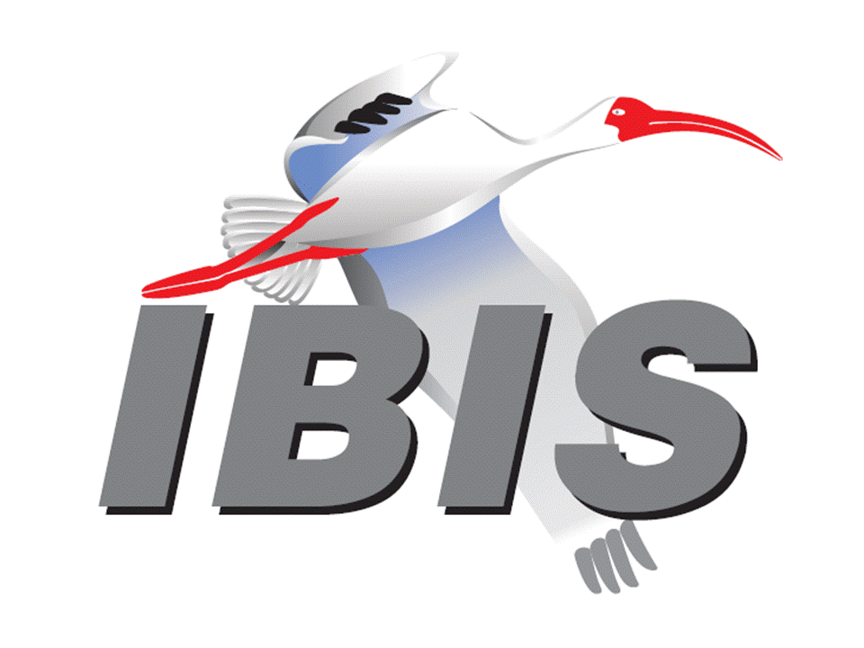**IBIS Hybrid Summit with DesignCon 2024**

February 2, 2024

**Agenda**

All times PST

|  |  |
| --- | --- |
| 8:00 AM | **SIGN IN AND BREAKFAST BUFFET**  Food available at 7:45 AM |
| 8:10 AM | **Welcome** Lance Wang (Zuken USA, USA)  (Chair, IBIS Open Forum) |
| 8:15 AM | **IBIS Chair’s Report**  Lance Wang (Zuken USA, USA)  (Chair, IBIS Open Forum) |
| 8:30 AM | **Enabling Cross Connected Differential Tx-Rx System Using IBIS [Series_switch]**   Raushan Kumar (STMicroelectronics, India)  Rahul Kumar (STMicroelectronics, India)  Manish Bansal (STMicroelectronics, India)  [Presented by Raushan Kumar] |
| 8:45 AM | **More IBIS History**  Bob Ross (Teraspeed Labs, USA) |
| 9:05 AM | **A Practical Review of IBIS DDR5 Enhancements**  Doug Burns (SI-Clarity, USA)  Pegah Alavi (Keysight Technologies, USA)  [Presented by Pegah Alavi] |
| 9:45 AM | **OFFICER GIFT and BREAK (20 minutes)** |
| 10:05 AM | **Using Measured Waveform Data in AMI Simulation for System Design**  Hee-Soo Lee (Keysight Technologies, USA)  Fangyi Rao (Keysight Technologies, USA)  Yoonman Choi (SK Hynix, Korea)  [Presented by Yoonman Choi] |
| 10:35 AM | **BIRD229: [AMI Test Configuration] – Standardizing Algorithmic Model Testing**  Michael Mirmak (Intel, USA) |
| 10:55 PM | **Update on BIRD226: PSIJ Sensitivity**  Kinger Cai (Intel, USA)  Fern Nee Tan (Intel, Malaysia)  Chi-te Chen (Intel, USA)  Michael Mirmak (Intel, USA)  [Presented by Kinger Cai] |
| 11:20 PM | **The Optimization of IBIS-AMI Model Parameters with Machine Learning Algorithms**  Jared James (Cadence Design Systems, USA)  Ambrish Varma (Cadence Design Systems, USA)  [Presented by Jared James] |
| 12:00 PM | **FREE LUNCH, NETWORKING** |
| 1:30 PM | **IBIS Quality 3.0 Checklist Spreadsheet**  Weston Beal (Siemens EDA, USA) |
| 2:05 PM | **Matrix Parameters in Touchstone (Updated)**  Bob Ross (Teraspeed Labs, USA) |
| 2:30 PM | **Update on BIRD223.1: Add Support for SPIM in IBIS**  Kinger Cai (Intel, USA)  Chi-te Chen (Intel, USA)  [Presented by Kinger Cai] |
| 2:45 PM | **Addressing the Challenges of PAM-3 USB 4.0 - Design and Analysis**  Zhiping Yang (MST EMC Lab and JAY Plus, USA)  Zhen Mu (Cadence Design Systems, USA)  Kyle Lake (Cadence Design Systems, USA)  **[Presented by Zhiping Yang]** |
| 3:15 PM | **OPEN DISCUSSION** |
| 3:30 PM | **CLOSING REMARKS**  - Next IBIS Open Forum Meeting Friday, February 16, 2024 |
|  | **END OF MEETING** |
|  |  |
|  |  |

