AGENDA - Asian IBIS Summit (Tokyo)
Friday, November 17, 2017

Akihabra UDX
Tokyo, Japan

Room: 4F UDX4F
Sponsors: Japan Electronics and Information Technology Industries Association (JEITA)
IBIS Open Forum

ANSYS
Cadence Design Systems
Cybernet Systems
Keysight Technologies
Ricoh
Toshiba Corporation
Zuken, Inc.
(Order and times subject to change)
13:30 SIGN IN
13:35 MEETING WELCOME
- Mitsuharu UMEKAWA (Keysight Technologies, Japan)
Chair, JEITA EDA Model Subcommittee
- Mike LaBONTE (SiSoft, USA)
Chair, IBIS Open Forum
13:45 IBIS Update
Mike LaBONTE (SiSoft, USA)
14:10 What’s Expected for IBIS-AMI from the Perspective of End-User Support
Masao NAKANE (Xilinx, Japan)
14:40 DDR System Simulations: What Issue to Simulate
Shinichi MAEDA (KEI Systems, Japan)
15:10 BREAK
- Reconvene at 15:30

15:30 Investigation of the Package Crosstalk Noise to DDR4-IF Signal by IBIS [Define Package Model]
Akiko TSUKADA, Masaki KIRINAKA (Fujitsu Interconnect Technologies Limited, Japan)
[Presented by Akiko TSUKADA (Fujitsu Interconnect Technologies Limited, Japan)]
16:15 On die De-cap Modeling Proposal
Kazuki MURATA (Ricoh Company, Japan)
16:40 Interconnect Modeling Update Using IBIS-ISS and Touchstone
Michael MIRMAK (Intel Corporation, USA)
[Presented by Mike LaBONTE (SiSoft, USA)]
17:15 CONCLUDING ITEMS
17:30 END OF IBIS SUMMIT MEETING
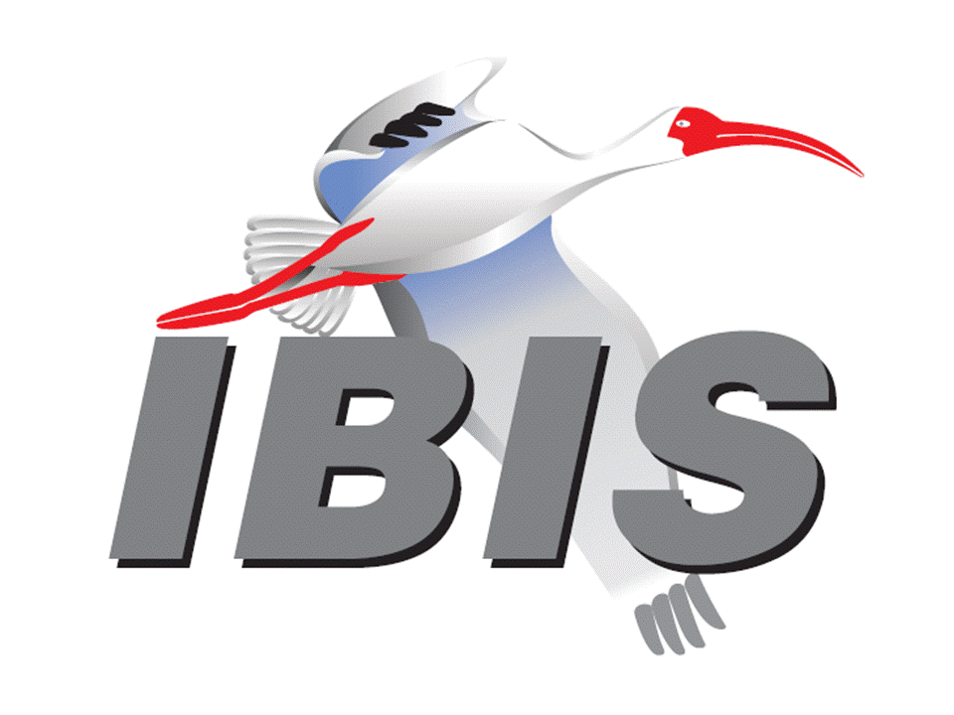
- Thank you for your participation

