AGENDA - Asian IBIS Summit (Taipei)
Friday, November 16, 2018

Sherwood Hotel
Taipei, Taiwan

Room: Ballroom 3F (3rd Floor, look for signs)
Sponsors: Cadence Design Systems
KairosTech Innovaton (SPISim)
Synopsys
(Order and times subject to change)
09:00 SIGN IN
- Vendor Tables Open at 9:00
09:30 MEETING WELCOME
LaBonte, Mike (Chair, IBIS Open Forum)
(SiSoft, USA)
09:45 IBIS Update
LaBonte, Mike (SiSoft, USA)
10:05 A Practical Methodology for SerDes Design
Amy Zhang*, Guohua Wang*, David Zhang*,
Zilwan Mahmod**, Anders Ekholm**
(Ericsson, *PRC, *Sweden)
[Presented by Amy Zhang (Ericson, PRC)]
10:35 BREAK
- Refreshments and Vendor Tables
- Reconvene at 10:55
10:55 Characterizing and Modeling of a Clamped Non-Linear CTE/AGC
Liang, Skipper (Cadence Design Systems, ROC)
12:00 FREE BUFFET LUNCH (hosted by sponsors)
- Reconvene at 13:20
13:20 Model Correlation for IBIS-AMI
Xie*, Wenyan; Wang*, Guohua; Zhang*, David; Ekholm**; Anders
(Ericsson, *PRC, **Sweden)
[Presented by Anders Ekholm (Ericsson, Sweden)]
14:10 BREAK
- Reconvene at 14:30
14:30 Study of DDR Asymmetric Rt/Ft in Existing IBIS-AMI Flow
Huang*, Wei-hsing; Shih**, Wei-kai
(SPISim, *USA, **Japan)
[Presented by Huang, Wei-hsing (SPISim, USA)]
15:00 DISCUSSION
15:20 CONCLUDING ITEMS
15:30 END OF IBIS SUMMIT MEETING
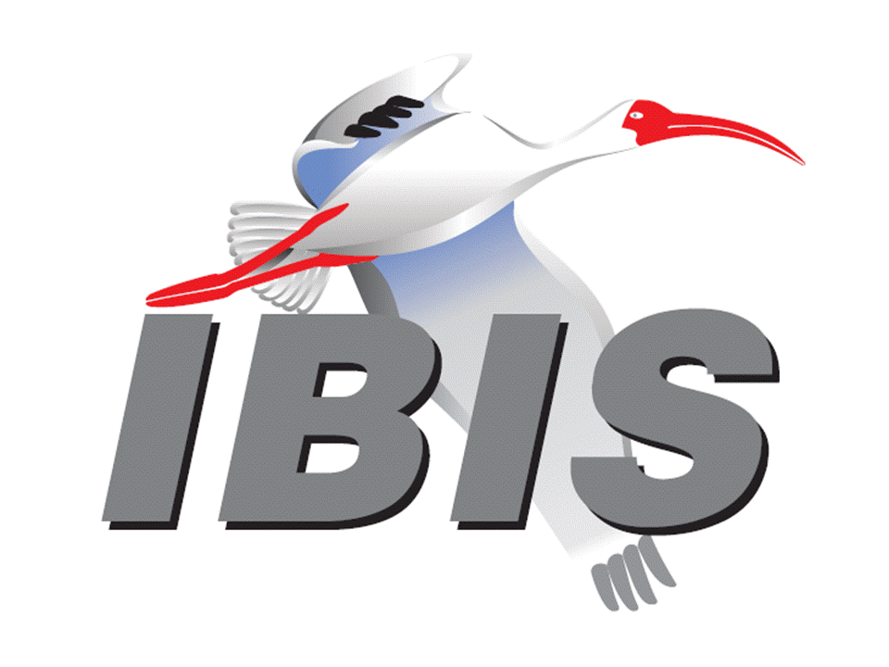
- Thank you for your participation

