Hybrid Asian IBIS Summit (Japan)
Tuesday, November 14, 2023

Agenda

Location: Ote Center Bldg. 1-1-3, Otemachi, Chiyoda-ku, Tokyo 100-0004, Japan
Room: JEITA Conference Room + Virtual
Sponsors: IBIS Open Forum
Japan Electronics and Information Technology Industries Association (JEITA)

ANSYS, Inc.
Apollo Giken Co., Ltd.
Keysight Technologies Japan K.K.
Seiko Epson Corporation
Toshiba Corporation
Zuken Inc.
(Most presentations are in pre-recorded audio/ video format with alternative language subtitles)
(Order and times in JST subject to change)
9:15 SIGN IN
9:25 MEETING WELCOME
Lance WANG (Chair, IBIS Open Forum, Zuken, USA)
9:30 Asian IBIS Summit – Japan, 2023 Meeting Welcomes
Hayato OGAWA (Keysight Technologies, Japan)
Chair, JEITA EDA Model Specialty Committee
9:40 IBIS Chair's Report
Lance WANG (Zuken, USA)
10:00 Matrix Parameters in Touchstone
Bob ROSS (Teraspeed Labs, USA)
10:20 Investigate EMD Model Specification
Masaki KIRINAKA (FICT Limited, Japan)
10:40 BREAK (10 minutes)
10:50 Standard Compliant IBIS-AMI Model for System Sign-off with
USB4 Gen2 as an Example
Zhifei XU (Ningbo DeTooLIC Technology Co., China)
Zhiping WANG (Missouri S&T EMC Lab and JAY Plus, USA)
[Presented by Zhifei XU]
11:10 Hardware and AI/ML: Applications of SIPI & IBIS
Zhiping YANG (Missouri S&T EMC Lab and JAY Plus, USA)
11:30 Q&A Session
11:45 Discussion Room with IBIS Open Forum
Facilitator: Satoshi ENDO (JEITA EDA Model Specialty Committee)

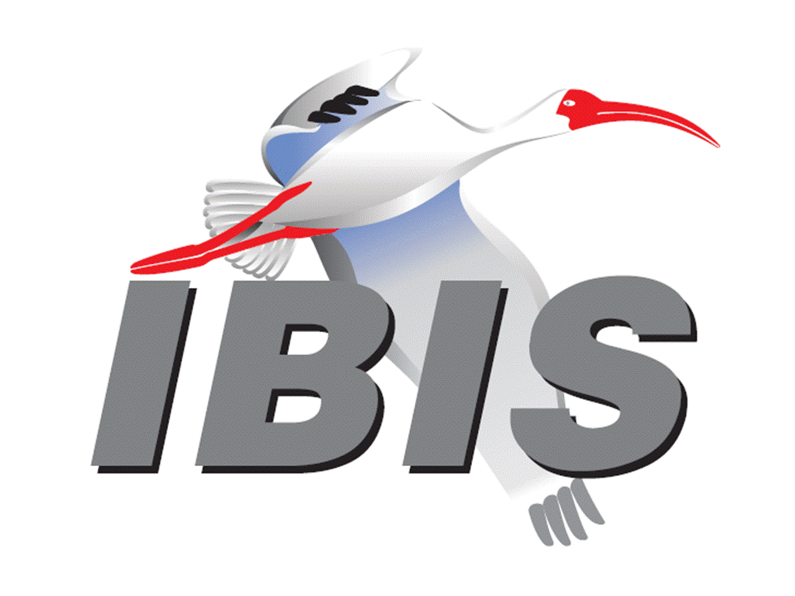
12:05 END OF IBIS SUMMIT MEETING

