BUFFER ISSUE RESOLUTION DOCUMENT (BIRD)

BIRD NUMBER: 223.1
ISSUE TITLE: Add support for SPIM in IBIS
REQUESTOR: Kinger Cai, Chi-te Chen, Intel Corp.
DATE SUBMITTED: March 7, 2023
DATE REVISED: September 12, 2023
DATE ACCEPTED: July 14, 2023 (223); November 17, 2023 (223.1)

DEFINITION OF THE ISSUE:
The current IBIS specification (v7.2) does not support full device level Power Integrity (PI) modeling of power rails in components or modules for full platform PI design simulations and optimization.
The existing power aware IBIS [Model]s involve only the power rails of the I/O interfaces and include only the analog front end circuit blocks. These models do not include additional power supply rails associated with other units, such as controller circuit blocks, reference circuit blocks, and computational circuit blocks, such as CPU, GPU, NPU, etc. Although it is critical to ensure the power delivery network (PDN) design quality for I/O rails, a big part of the platform level PI and power delivery (PD) design optimizations focus on the rails of computational blocks.
Currently, most device vendors only provide PI design guidelines in physical equivalence for each power rail for a recommended stackup, in terms of PDBOM (Power Delivery Bill of Materials), capacitor placement constraints, and a reference routing. This approach leaves no flexibility for platform board designers to make tradeoffs between performance, cost, system form factors (FF) such as stackup, routing area, PDBOM and capacitor placement. Even if the PDBOM, capacitor placement, and stackup are copied exactly from a reference design, there is no PI model or tools available to verify whether the platform PI design meets the desired electrical performance.
This BIRD intends to extend the IBIS specification to support full platform PI design and optimization with the flexibility to make tradeoff decisions among cost, performance, and form factor, based on published platform level power integrity design architectures. The BIRD addresses the challenges of full platform PI design with a new device and/or module level Streamlined Power Integrity Model (SPIM), optionally provided through a new .spim file, using several new keywords.

SOLUTION REQUIREMENTS:
The proposed SPIM requires only a minimum amount of information from the device or module vendors for intellectual property protection, while it contains sufficient PI design collaterals to support platform level PI simulations and analysis, PDN design optimization, review, and signoff.

Table 1: Solution Requirements
Requirements | Notes
To enable platform level PI design with SPIM using published platform PI design architectures, the IBIS specification is extended to define the Streamlined PI Model (SPIM).
SPIM defines device or module level standard PI model between [Device SPIM] and [End Device SPIM]. It includes the definition of each individual SPIM, of multiple power rails one-by-one, between the [SPIM Rail] and [End SPIM Rail] keyword pair.
To support full PDN design with AC analysis, the definition for each power rail includes
- [SPIM Pin Cluster] with [End SPIM Pin Cluster],
- [SPIM Port List] with [End SPIM Port List] and the corresponding list of OB_Stimulus_#_p/n, and OB_Sense_#_p/n ports,
- [SPIM Touchstone File] with [End SPIM Touchstone File]
- [SPIM Stimulus] with [End SPIM Stimulus]
- [SPIM Target] with [End SPIM Target], and [SPIM Observation Port] defined in-between for the case of multiple OB_Sense ports

To support full PDN design with DC analysis including current distribution and IR drop analysis, the definition for each power rail will expand to include:
- [SPIM Rnetwork File] with [End SPIM Rnetwork File]
- [SPIM Current] with [End SPIM Current], and
- [SPIM Voltage List] with [End SPIM Voltage List]

PROPOSED CHANGES:
- INTRODUCTION
The concept of the Streamlined Power Integrity Model (SPIM) is illustrated in Figure-1[1]. The holistic platform PDN usually includes three major segments: device level SPIM including package PDN routing with or sometimes without decoupling capacitors on board PDN routing with decoupling capacitors of multi-layer ceramic capacitors (MLCC) in different form factors, and voltage regulator module (VRM) including voltage regulator (VR) controller and bulk inductor (Lbulk) and bulk capacitors (Cbulk).
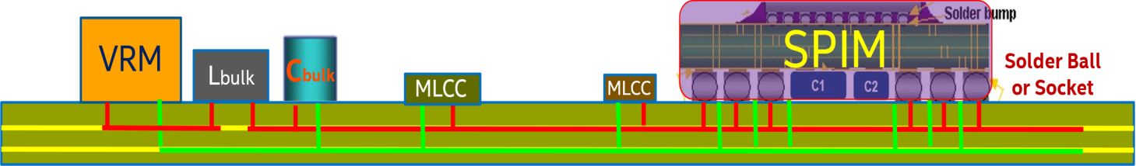
Figure-1. SPIM in platform Power Delivery Network (PDN)
For supporting full PDN design with AC impedance analysis in frequency domain and transient analysis in time domain, SPIM should include the description of the PDN in Touchstone (typically S-parameter) format for an example as shown in Figure-2, using three types of ports. The ports of the first type include the clustered power pins with reference to local clustered GND pins of the device or module and are used for making connections with the corresponding clustered power and GND pins of the Printed Circuit Board (PCB). The ports of the second type are clustered stimulus ports, called OB_Stimulus, which are usually set up at die pads or buffer terminals and are used for connecting to the weighted AC or transient loading current sources. The sum of the weighting values of all stimulus ports equals 1 for AC impedance analysis. The ports of the third type, called OB_Sense, are observation sensing ports, which are usually set up for the location where the design target is defined.
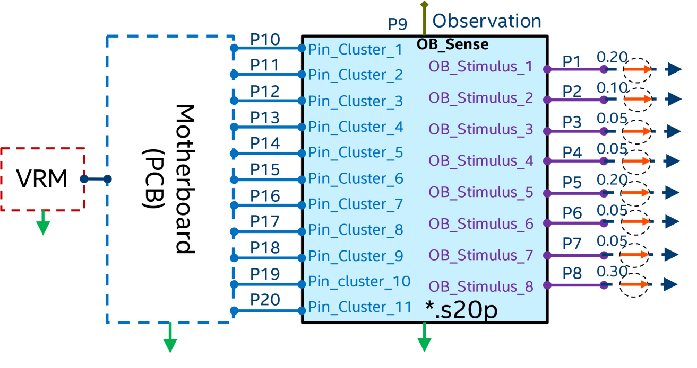
Figure-2. Example SPIM for AC analysis with functional ports defined.
In order to achieve a balance between accuracy and efficiency, the balls or pins are usually clustered. Each power ball or pins’ cluster is used as a positive terminal to set up a pin-level port by reference to the local negative terminal of the nearest GND ball or pins’ cluster. As shown in Figure-3, given the power signal name is VCC3, and GND signal name is VSS, the example SPIM pin clusters are listed as
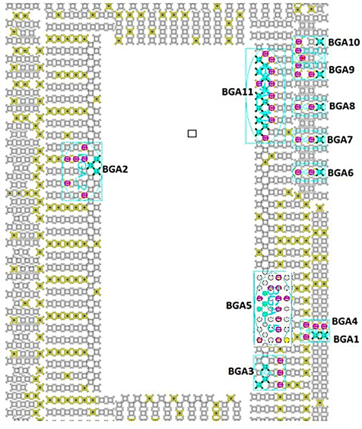
VCC3_1 AK1
VSS_VCC3_1 AM1 AM4 AK4

VCC3_2 BY39 BV39 BW40
VSS_VCC3_2 CB41 BY41 BP41 BY42 BY44 BT44

VCC3_3 AC10 AE10 AB12
VSS_VCC3_3 AB8 AD8 AF8

VCC3_4 AK2
VSS_VCC3_4 AM1 AM2 AM4

| …

VCC3_11 CY1
VSS_VCC3_11 CY5 CV5 CU4
Figure-3. Example clusters at pin level

With the generalized platform PDN setup, as shown in Figure-4, the SPIM has as many pin-level ports at location-1 as needed for making the connections with the PCB, has N stimulus ports at location-2 and has M observation ports. The S-parameter model of the PCB usually has K ports for decoupling capacitors, in addition to the ports at the pin level for connecting with the SPIM and one or multiple ports for connecting to the voltage regulator module (VRM).
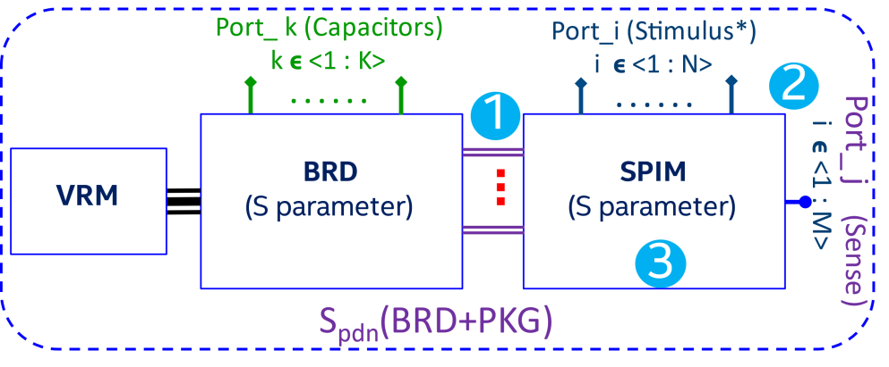
Figure-4. Generalized platform PDN setup

The S-parameter model of SPIM and the S-parameter model of the PCB may be cascaded into one S-parameter model S_{pdn} of the complete PDN with VRM ports terminated with proper VRM models. VRM modeling has been addressed in an IEEE conference paper VRM Modeling for Platform FastPI upon SPIM [2]. Typically, PDN design focuses on the impedance at the observation sensing ports, therefore the PDN S-parameter model S_{pdn} is converted to a N+M port PDN Z-parameter model Z_{pdn}, after applying VRM models at all VRM ports, for N observation stimulus ports and M observation sensing ports are present in the whole platform PDN. As shown in equation (5), the sum of the weighting values defined for each of the N observation stimulus ports shall be 1. The impedances at the observation sensing ports are derived through equations (1) to (7) shown below.
[S_{pdn}] [Z_{pdn}] (1)
[V] = [Z_{pdn}][I] (2)
[V] = [v₁, v₂, …, v_{N}’ v_{S1}, v_{S2}, …, v_{SM}]^{T} (3)
[I] = [W₁, W₂, …, W_{N}, 0, 0, …, 0]^{T} (4)
$\sum_{i=1}^{i=N}{Wi=1}$ (5)
Z_{Sj}= V_{Sj}= $\sum_{i=1}^{i=N+M}{\left(Zpdn\left(N+j\right),i*Wi\right)}$, jϵ<1:M> (6)
Z_{Sj}= $\sum_{i=1}^{i=N}{\left(Zpdn\left(N+j\right),i*Wi\right)}$, jϵ<1:M> (7)
The holistic platform PDN usually includes three major segments: on-die power grid routing with decoupling capacitance, package PDN routing with or sometimes without decoupling capacitors, and on board PDN routing with decoupling capacitors and a VRM. As shown in Figure-5, the platform impedance curve observed at the a given sensing port will vary depending on how many of these segments are included. A typical platform PDN usually has three major impedance peaks. The first peak is in Zone-1, beyond 10 MHz or sometimes 20 MHz, as illustrated by the curve in red, which will not appear if the on-die PDN segment is excluded in the PI analysis. The second peak is in Zone-2, usually in the frequency range of 1 MHz to 10 MHz, which will not appear if both on-die and package PDN segments are excluded in the PI analysis. The third peak is in Zone-3, below 1 MHz, which results from the interaction between VRM and bulk capacitors on PCB [3].
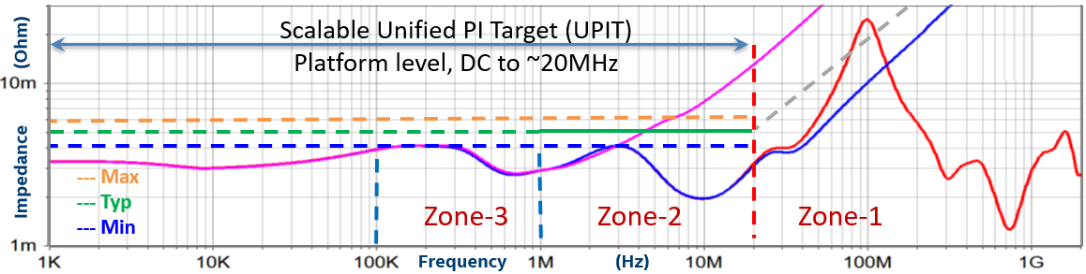
Figure-5. Platform impedance curves with scalable Unified PI Target (UPIT)

SPIM is intended to provide minimum yet sufficient PI design collaterals to support platform PDN design optimization, review, and signoff, after the device level design has been completed for the package as well as the silicon. In other words, the device level PDN design cannot be influenced or changed by the board level PDN design. Meanwhile, Figure-5 also indicates that there is a significant interaction between package PDN segment and board PDN segment in the frequency range of approximately 2 MHz to 20 MHz, which might vary for different device designs.
Therefore, a typical Unified PI Target (UPIT) shall be defined in a Piece Wise Linear (PWL) function, according to the definition in equation (7), usually up to approximately 20 MHz from DC or below 10 kHz. This includes the VRM impact on PDN impedance for the power supply rails of computational blocks as well as I/O interfaces. The default PI design target is a typical target, though UPIT is also scalable, and may be provided in Typ, Max and Min respectively. The typical target supports the typical performance based on the specified platform design guideline for a particular power rail in a product. The maximum target is for cost optimal PDN designs, supporting high-volume, cost sensitive and less performance-oriented product segments. The minimum target is for performance oriented PDN designs supporting high performance, less cost sensitive premium product segments.
For supporting DC analysis, the SPIM may include a description of the PDN in a resistance network format, using a SPICE subcircuit for all three types of terminals, as shown in Figure-6. The terminals of the first type are set up for every power pin and every GND pin and used for making connections with the corresponding power and GND pins of the PCB. Consequently, the current going through each power or GND pin is observable in DC simulation, which need to be within the Imax specification through PDN design optimization. The terminals of the second type are clustered stimulus terminals called OB_Stimulus_<1: N>_p/n, which are usually set up at die pads or buffer terminals and used for connecting the weighted DC loading current sources. The terminals of the third type called OB_Sense_<1:M>_p/n are observation terminals, which are usually set up for the location where the design target is defined. The sum of the weighting values of all stimulus terminal pairs must equal 1. The actual DC current for each pair of stimulus terminals will be calculated by multiplying its weighting value with the total DC loading current.
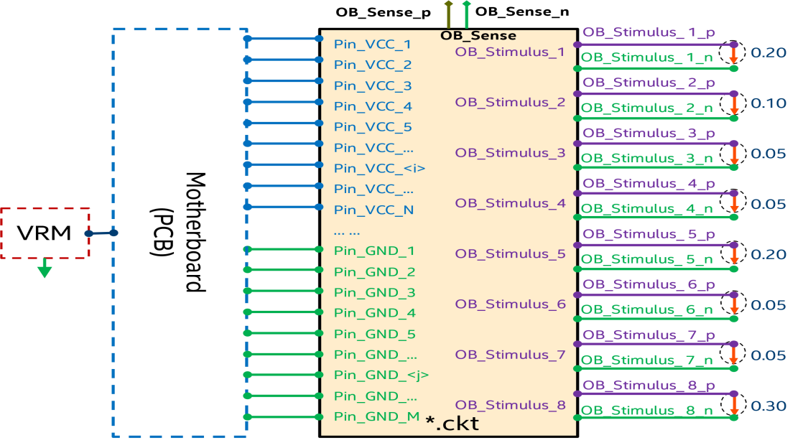
Figure-6. One example SPIM for DC analysis with functional terminals defined.

Table 2 – SPIM Keywords and Subparameters
Keywords or subparameters | Notes
[Device SPIM Group] | Optional in a .ibs file, illegal in a .spim file
[Device SPIM] | Required in a .spim file, illegal in a .ibs file
[Manufacturer] | Optional within any [Device SPIM]
[Description] | Optional within any [Device SPIM]
[SPIM Rail] | At least one [SPIM Rail] is required for each [Device SPIM]
[SPIM Pin Cluster] | Required for each [SPIM Rail] for AC analysis
[SPIM Port List] | Required for each [SPIM Rail] for AC analysis
[SPIM Touchstone File] | File_TS subparameter is required for each [SPIM Rail] for PDN design with AC or transient analysis
[SPIM Stimulus] | Optional for each [SPIM Rail] for AC analysis
[SPIM Target] | Required for each [SPIM Rail] for AC analysis
[SPIM Observation Port] | Required for each OB_Sense port of each [SPIM Rail] for AC analysis, if there are more than one OB_Sense ports defined
[SPIM Rnetwork File] | File_IBIS_ISS subparameter is required for each [SPIM Rail] for PDN design with DC analysis
[SPIM Current] | Required for each [SPIM Rail] for DC analysis
[SPIM Voltage List] | Required for each [SPIM Rail] for DC analysis
OB_Stimulus_<#>_P/n | Required for each [SPIM Port List] for AC analysis
OB_Sense<_#>_p/n | Required for each [SPIM Port List] for AC analysis
File_TS | Required when [SPIM Touchstone File] keyword is used
File_IBIS_ISS | Required when [SPIM Rnetwork File] keyword is used
[End SPIM Voltage List] | Required when [SPIM Voltage List] keyword is used
[End SPIM Current] | Required when [SPIM Current] keyword is used
[End SPIM Rnetwork File] | Required when [SPIM Rnetwork File] keyword is used
[End SPIM Target] | Required when [SPIM Target] keyword is used
[End SPIM Stimulus] | Required when [SPIM Stimulus] keyword is used
[End SPIM Touchstone File] | Required when [SPIM Touchstone File] keyword is used.
[End SPIM Port List] | Required when [SPIM Port List] keyword is used.
[End SPIM Pin Cluster] | Required when [SPIM Pin Cluster] keyword is used.
[End SPIM Rail] | Required when [SPIM Rail] keyword is used.
[End Device SPIM] | Required when [Device SPIM] keyword is used.
[End Device SPIM Group] | Required when [Device SPIM Group] keyword is used in .ibs file

The following tree structure shall be used for .spim files:
spim FILE
├── File Header Section
│ ├── [IBIS Ver]
│ ├── [Comment Char]
│ ├── [File Name]
│ ├── [File Rev]
│ ├── [Date]
│ ├── [Source]
│ ├── [Notes]
│ ├── [Disclaimer]
│ └── [Copyright]
│
├── [Device SPIM]
│ ├── [Manufacturer]
│ ├── [Description]
│ │
│ ├── [SPIM Rail]
│ │ ├── [SPIM Pin Cluster]
│ │ │ └── [End SPIM Pin Cluster]]
│ │ │
│ │ ├── [SPIM Port List]
│ │ │ └── [End SPIM Port List]
│ │ │
│ │ ├── [SPIM Touchstone File]
│ │ │ │
│ │ │ ├── [SPIM Stimulus]
│ │ │ │ └── [End SPIM Stimulus]
│ │ │ ├── [SPIM Target]
│ │ │ │ ├── [SPIM Observation Ports]
│ │ │ │ └── [End SPIM Target]
│ │ │ │
│ │ │ └── [End SPIM Touchstone File]
│ │ │
│ │ ├── [SPIM Rnetwork File]
│ │ │ │
│ │ │ ├── [SPIM Current]
│ │ │ │ └── [End SPIM Current]
│ │ │ ├── [SPIM Voltage List]
│ │ │ │ └── [End SPIM Voltage List]
│ │ │ │
│ │ │ └── [End SPIM Rnetwork File]
│ │ │
│ │ └── [End SPIM Rail]
│ │
│ └── [End Device SPIM]
│
└── [End]

Add to ibs FILE [Device SPIM Group] under [Component]:

ibs FILE
│…..
│
├── [Component] Si_location, Timing_location
│ │
│ │ …..
│ │
│ ├── [Device SPIM Group]
│ │ └── [End Device SPIM Group]
│ │ …..
│ │

A device refers to a component which includes package from pins to bumps and the silicon atop, or a module from pins to components atop. SPIM mainly focuses on power delivery network. When [Device SPIM Group] definitions occur within a .ibs file, their scope is “local”— they are known only within that .ibs file and no other .ibs file.
Usage Rules for the .spim file:
SPIM models are stored in a file whose file whose name looks like:
<stem>.spim
The <stem> provided shall adhere to the rules given for the [File Name] keyword. Use the “spim” extension to identify files containing SPIM models. The .spim file shall contain all of the required elements of a normal .ibs file, including [IBIS Ver], [File Name], [File Rev], and the [End] keywords. Optional elements include the [Date], [Source], [Notes], [Disclaimer], [Copyright], and
[Comment Char] keywords. All the elements follow the same rules as those for a normal .ibs file.
Note that the [Component] and [Model] keywords are not allowed in the .spim file. The .spim file is for SPIM models only.

Keyword: [Device SPIM Group]
Required: No, but it is required for including an SPIM model in a .ibs file.
Description: In a .ibs file, a selector under [Component] to select the device SPIM models, which are in a separate .spim file. In a .ibs file, the [Device SPIM Group] keyword is permitted multiple times.
The [Device SPIM Group] keyword is used to define a list of [Device SPIM] models by name that shall be used together for all concerned power rails of one particular configuration on a platform.
Usage Rules: The [Device SPIM Group] keyword accepts a single string argument, which is device SPIM group name. The string argument shall be no longer than 40 characters and shall not include whitespace.
For each existing [Device SPIM Group], there are usually two columns. The first column lists the Device SPIM name uniquely in string argument one by one, each of them shall be no longer than 40 characters and shall not include whitespace. The second column refers to the relevant .spim file name, either in the same folder of the local .ibs file or a spim_folder, a subfolder underneath the folder where the local .ibs file is located, will be specified.
Example:
[Device SPIM Group] Group_name_1 | selector under [Component]
| …
Device_SPIM_name_1 spim_folder/file_name_1.spim | it is in a .spim file.
| … RELATIVE to the .ibs file
| …
[End Device SPIM Group]

[Device SPIM Group] Group_name_2 | selector under [Component]
| …
Device_SPIM_name_2 spim_folder/file_name_2.spim | it is in a .spim file
| … RELATIVE to the .ibs file
| …
[End Device SPIM Group]

Keyword: [End Device SPIM Group]
Required: No. But it is required if a [Device SPIM Group] keyword is present.
Description: Indicates the end of the data for one [Device SPIM Group].
Example:
[End Device SPIM Group]

Keyword: [Device SPIM]
Required: No, but it is required in a .spim file.
Description: Marks the beginning of device level SPIM for a particular device or module.
Usage Rules: The [Device SPIM] keyword accepts a single string argument which is a Device SPIM name. This string argument shall be no longer than 40 characters and shall not include whitespace.
The [Device SPIM] / [End Device SPIM] keyword pair shall appear only once in a .spim file for one device or module, with a unique Device SPIM name.
All content, defined between [Device SPIM] and [End Device SPIM] keyword pair in a .spim file, shall not be copied or inserted into a .ibs file of the same [Component], instead should be called by Device SPIM name between the [Device SPIM Group] and [End Device SPIM Group] keyword pair in a .ibs file.
Example:
[Device SPIM] My_CPU2
| …
[End Device SPIM]

Keyword: [End Device SPIM]
Required: No, but it is required if the [Device SPIM] keyword is present.
Description: Indicates the end of the data after [Device SPIM].
Example:
[End Device SPIM]

Keyword: [Manufacturer]
Required: No.
Description: Specifies the name of the [Device SPIM] manufacturer.
Usage Rules: The length of the manufacturer’s name shall not exceed 40 characters, while blank characters are allowed.
Example:
[Manufacturer] MyName Corp.

Keyword: [Description]
Required: No.
Description: Provides a concise yet easily human-readable description of what kind of device SPIM [Device SPIM] represents.
Usage Rules: The description shall fit on a single line and may contain spaces.
Example:
[Description] 220 pin myCPU

Keyword: [SPIM Rail]
Required: No, but it is required in a .spim file.
Description: Marks the beginning of SPIM for one power rail. The [SPIM Rail] keyword may be defined many times in a .ibs file or in a .spim file.
Usage Rules: The [SPIM Rail] keyword accepts a single string argument, which is a signal_name or bus_label name from the [Pin] keyword, or the [Pin Mapping] keyword, or [Bus Label] keyword. This string argument shall be no longer than 40 characters and not include whitespace.
This keyword may appear multiple times between the [Device SPIM] and [End Device SPIM] keyword pair, one for each particular power rail. The power signal name argument may not be duplicated for a [SPIM Rail] keyword within the same [Device SPIM] and [End Device SPIM] keyword pair.
Other Notes: A complete [SPIM Rail] [End SPIM Rail] keyword pair description normally contains the following keywords: [SPIM Pin cluster] [SPIM Port List], [SPIM Touchstone File], and [SPIM Rnetwork File]. Within the [SPIM Touchstone File] and [End SPIM Touchstone File] keyword pair, there are two keywords of [SPIM Stimulus] and [SPIM target]. Within the [SPIM Rnetwork File] and [End SPIM Rnetwork File] keyword pair, there are [SPIM Current] and [SPIM Voltage List].
Example:
[Device SPIM] My_CPU1
| …
[SPIM Rail] VCC3
| …
[End SPIM Rail]
| …
[SPIM Rail] VDD2
| …
[End SPIM Rail]
| …
[End Device SPIM]

Keyword: [End SPIM Rail]
Required: No, but it is required if the [SPIM Rail] keyword is present.
Description: Indicates the end of the data after [SPIM Rail].
Example:
[End SPIM Rail]

Keyword: [SPIM Pin Cluster]
Required: No, but it is required in a .spim file.
Description: Marks the beginning of SPIM pins clustering for a particular power rail as specified in [SPIM Rail], and its reference GND rail. The following lines list the Pin_cluster_name and Pin_name_List in the format of:
< Power_name>_<#>, followed by a power pins list. Power signal name should match the single string argument following the [SPIM Rail] keyword.
< GND_name>_ <Power_name>_<#>, followed by a GND pins list.
The [SPIM Pin Cluster] keyword is only defined once for each [SPIM Rail].
Usage Rules: The [SPIM Pin Cluster] keyword accepts one single string argument, which is the GND signal name. The string argument shall be no longer than 40 characters and not include whitespace.
The number of <#> is an integer number starting from 1. While not prohibited, numbers should not be omitted; in other words, the clusters shall be numbered sequentially.
Every given Power pin, associated with the particular power signal, shall be and shall only be, associated with one unique cluster of <Power_name>_<#>.
A GND pin may appear in more than one cluster of <GND_name>_ <Power_name>_<#>. Not all GND pins need to be included in [SPIM Pin Cluster].
Example:
[SPIM Pin Cluster] VSS
| Pin_cluster_name Pin_name_List
VCC3_1 AK1
VSS_VCC3_1 AM1 AM4 AK4

VCC3_2 AC10 AE10 AB12
VSS_VCC3_2 AB8 AD8 AF8

VCC3_3 AK2
VSS_VCC3_3 AM1 AM2 AM4

| …

VCC3_11 CY1
VSS_VCC3_11 CY5 CV5 CU4

[END SPIM Pin Cluster]

Keyword: [End SPIM Pin Cluster]
Required: No, but it is required if the [SPIM Pin cluster] keyword is present.
Description: Indicates the end of the data after [SPIM Pin Cluster].
Example:
[End SPIM Pin Cluster]

Keyword: [SPIM Port List]
Required: No, but it is required in a .spim file.
Description: Marks the beginning of SPIM Port List for every particular port, in the same order as that being specified in the associated [SPIM Touchstone File], between each pair of positive terminal Terminal_p and its own local reference negative terminal Terminal_n.
The following lines list ports in the format of Port#, Terminal_p, and Terminal_n.
Usage Rules: Port#, or Port number, shall match the port order number as being defined in the SPIM Touchstone file, which is specified in [SPIM Touchstone File]. The order of number, or # in [SPIM Port List] is recommended to start from 1 sequentially.
For the prefix of terminal name keywords OB_Stimulus_<#>_p/n and OB_Sense<_#>_p/n are defined and required to further specify the stimulus and sensing terminals and ports functions.
The terminal names for pins in general should use <Power_signal_name>_<#> for positive terminal and <GND_signal_name>_ <Power_signal_name>_<#>, which shall match those being defined in [SPIM Rail] and [SPIM Pin Cluster], respectively.
While not being prohibited, numbers (represented by <#> in the description) should not be omitted; in other words, the ports shall be numbered sequentially.
At least one stimulus port OB_Stimulus_1, one observation sense port OB_Sense and one pin port shall be defined in [SPIM Port List]. An SPIM Touchstone File shall have 3 or more ports.
Each port is physically defined between its positive terminal and its own local negative terminal.
All pins’ Terminal_p and Terminal_n names should match those defined in [SPIM Pin Cluster].
OB_Stimulus_<#> ports shall be defined between the terminals of OB_Stimulus_<#>_p/n locally.
OB_Sense<_#> ports shall be defined between the terminals of OB_Sense<_#>_p/n locally.
OB_Sense port is recommended to be placed where the sensing signal is observed physically for correlation between pre-Si design and post-Si validation, but this is not a mandatory requirement. OB_Sense port is a probing or observing port in general, where the impedance is observed, and the impedance target is defined with all weighted stimuli being applied at all stimulus ports.
Pin_<#> ports shall be defined between the terminals of <Power_signal_name>_<#>, and < GND_signal_name>_ <Power_signal_name>_<#> locally.
The OB_Stimulus ports and OB_Sense ports are mandatorily specified by the prefix of terminal names, and all the remaining ports are used to make connections between a package/module and a PCB board.
The [SPIM Port List] keyword is only defined once for each [SPIM Rail].
Example:
[SPIM Port List]
| Port# Terminal_p Terminal_n
1 OB_Stimulus_1_p OB_Stimulus_1_n
2 OB_Stimulus_2_p OB_Stimulus_2_n
3 OB_Stimulus_3_p OB_Stimulus_3_n
4 OB_Stimulus_4_p OB_Stimulus_4_n
5 OB_Stimulus_5_p OB_Stimulus_5_n
6 OB_Stimulus_6_p OB_Stimulus_6_n
7 OB_Stimulus_7_p OB_Stimulus_7_n
8 OB_Stimulus_8_p OB_Stimulus_8_n
13 VCC3_4 VSS_VCC3_4
14 VCC3_5 VSS_VCC3_5
15 VCC3_6 VSS_VCC3_6
16 VCC3_7 VSS_VCC3_7
10 VCC3_1 VSS_VCC3_1
11 VCC3_2 VSS_VCC3_2
12 VCC3_3 VSS_VCC3_3
17 VCC3_8 VSS_VCC3_8
18 VCC3_9 VSS_VCC3_9
19 VCC3_10 VSS_VCC3_10
20 VCC3_11 VSS_VCC3_11
9 OB_Sense_p OB_Sense_n
[End SPIM Port List]

Keyword: [End SPIM Port List]
Required: No, but it is required if the [SPIM Port List] keyword is present.
Description: Indicates the end of the data after [SPIM Port List].
Example:
[End SPIM Port List]

Keyword: [SPIM Touchstone File]
Required: No, but it is required for full PDN design with AC or transient analysis in a .spim file.
Description: Declares the SPIM Touchstone file_type, and file_reference with its optional file path.
The [SPIM Touchstone File] keyword is only defined once for each [SPIM Rail].
Usage Rules: Specify the file type with FILE_TS to the file reference of the SPIM Touchstone File name with optional file path.
Each power rail shall have one and only one associated [SPIM Touchstone File].
File_TS is followed by one unquoted string argument, which is the file_reference for a Touchstone file. The Touchstone file under file_reference shall be in the same directory as the referencing .spim file or in a specified directory under the referencing file as determined by the directory path (i.e., a file reference containing a relative path to a directory below that of the referencing .spim file is permitted).
Other Notes: Within [SPIM Touchstone File] and [End SPIM Touchstone File] keyword pair, there are two keywords of [SPIM Stimulus] and [SPIM Target]. Further within [SPIM Target] and [End SPIM Target] keyword pair, there is keyword of [SPIM Observation Ports].
Example:
[SPIM Touchstone File]
| file_type file_reference
File_TS My_CPU2_VCC3_PKG.s20p
| …
[END SPIM Touchstone File]

| **** Below is an example usage in SPICE simulation ********
| Connecting S model with one global Reference in IBIS-ISS is commonly.
| used in Power Integrity analysis and design.
| *** Below explains how to use the *.snp s-element model in IBIS-ISS.
| .model pkg_module S N=20 tstonefile='My_CPU2_VCC3_PKG.s20p'
| S_one_ref
| + OB_Stimulus_1 OB_Stimulus_2 OB_Stimulus_3 OB_Stimulus_4
| + OB_Stimulus_5 OB_Stimulus_6 OB_Stimulus_7 OB_Stimulus_8
| + OB_Sense
| + BGA_1 BGA_2 BGA_3 BGA_4 BGA_5 BGA_6 BGA_7 BGA_8 BGA_9 BGA_10 BGA_11
| + 0
| + mname=pkg_module
| *****************************

Keyword: [End SPIM Touchstone File]
Required: No. but it is required if the [SPIM Touchstone File] keyword is present.
Description: Indicates the end of the data after [SPIM Touchstone File].
Example:
[End SPIM Touchstone File]

Keyword: [SPIM Stimulus]
Required: No.
Description: Declares the weightings of all OB_Stimulus ports.
By default, if there is no [SPIM Stimulus] specified or blank, the weighting of each port is assumed to be 1/N in default, where N is the total number of OB_Stimulus ports defined in [SPIM Port List].
The [SPIM Stimulus] keyword is only defined once for each [SPIM Rail].
Usage Rules: Specify the weightings in the format:
|OB_Stimulus_Port Weights.
All weighting values for all OB_stimulus should be specified numerically, neither blank nor NA, if all stimulus sources are unevenly distributed. Or none of weighting values for all OB_stimulus should be specified, if all stimulus sources are evenly distributed, and consequently the keyword of [SPIM Stimulus] should be also left as blank. The sum of all weighting values should equal to 1 in total.
OB_Stimulus_Port names shall be matching one-by-one with those defined by prefix OB_Stimulus_<#> in [SPIM Port List].
Example:
[SPIM Stimulus]
| OB_Stimulus_Port Weighting
OB_Stimulus_1 0.20
OB_Stimulus_2 0.10
OB_Stimulus_3 0.05
OB_Stimulus_4 0.05
OB_Stimulus_5 0.20
OB_Stimulus_6 0.05
OB_Stimulus_7 0.05
OB_Stimulus_8 0.30
[End SPIM Stimulus]

Keyword: [End SPIM Stimulus]
Required: No, but it is required if the [SPIM Stimulus] keyword is present.
Description: Indicates the end of the data after [SPIM Stimulus].
Example:
[End SPIM Stimulus]

Keyword: [SPIM Target]
Required: No, but it is required in a .spim file.
Description: Declares the PI design target in frequency for each OB_Sense port.
OB_Sense port shall be specified with [SPIM Observation Port], even if there is only one OB_Sense port defined.
The format is:
| Z(Frequency) Z(typ) Z(min) Z(max).
A Z(typ) column of values is required for a typical PI design target with magnitude in Ohms, while Z(min) or Z(max) column of values is optional for tight PI design target supporting higher performance and relaxed PI design target supporting compromised performance. If no numerical values are specified for Z(min) or Z(max) column, NA shall be listed in each row, instead of leaving them blank.
The [SPIM Target] keyword is only defined once for each [SPIM Rail].
Usage Rules: SPIM target is listed as piecewise linear (PWL) table, in terms of Frequency and Impedance amplitude Z.
Specify PI design target impedance magnitude vs. frequency in piecewise linear format.
OB_Sense name shall match those defined in Port_function in [SPIM Port List].
At least the Z(typ) impedance target should be defined numerically for one OB_Sense<_#> port.
The impedance target should have at least two Z(typ) impedance values at two different frequency points being defined in the table.
One OB_Sense port is permitted to have multiple targets defined, in Z(typ), Z(min) and Z(max).
Example:
[SPIM Target]
[SPIM Observation Port] OB_Sense
| Z(Frequency) Z(typ) Z(min) Z(max)
10000 0.0069 NA NA
1000000 0.0069 NA NA
6500000 0.0130 NA NA
10000000 0.0285 NA NA
20000000 0.0285 NA

[SPIM Observation Port] OB_Sense_2
| Z(Frequency) Z(typ) Z(min) Z(max)
10000 0.0069 0.0050 0.0080
1000000 0.0069 0.0050 0.0080
6500000 0.0130 0.0100 0.0200
10000000 0.0285 0.0200 0.0400
20000000 0.0285 0.0200 0.0400
[End SPIM Target]

Keyword: [End SPIM Target]
Required: No, but it is required if the [SPIM Target] keyword is present.
Description: Indicates the end of the data after [SPIM Target].
Example:
[End SPIM Target]

Keyword: [SPIM Rnetwork File]
Required: No, but it is required for DC analysis in a .spim file.
Description: Declares the IBIS-ISS subckt for the DCR (DC resistance) network.
The DCR network file defines the terminals at every pin for both the concerned power net and the reference GND net, besides defining the resistance network among all defined terminals. The DCR network file also defines the terminals for stimulus and observation ports with the same clustering as that for S-parameter ports definition.
Usage Rules: Specify the path to the circuit file and its name.
Each power rail shall have one and only one associated [SPIM Rnetwork File].
The File_IBIS-ISS subparameter is followed by two unquoted string arguments consisting of the file_reference and circuit_name (.subckt name) for an IBIS-ISS file. The IBIS-ISS file under file_reference shall be in the same directory as the referencing .ibs file or .spim file or in a specified directory under the referencing file as determined by the directory path (i.e., a file reference containing a relative path to a directory below that of the referencing .ibs or .spim file is permitted). The [SPIM Rnetwork File] keyword is only defined once for each [SPIM Rail].
Other Notes: Within [SPIM Rnetwork File] and [End SPIM Rnetwork File] keyword pair, there are [SPIM Current] and [SPIM Voltage List].
Example:
[SPIM Rnetwork File]
| file_type file_reference circuit_name(.subckt name)
File_IBIS-ISS My_CPU2_VCC3.iss VCC3_PKG_Rnetwork
| …
[End SPIM Rnetwork File]

Keyword: [End SPIM Rnetwork File]
Required: No, but it is required if the [SPIM Rnetwork File] keyword is present.
Description: Indicates the end of the data after [SPIM Rnetwork File].
Example:
[End SPIM Rnetwork File]

Keyword: [SPIM Current]
Required: No, but it is required for DC analysis in a .spim file.
Description: Declares the total average DC current of the concerned power rail.
It is defined in the format:
| I(name) I(typ) I(min) I(max)
I(name) specifies the power signal name.
I(typ) is required in Amperes, to define the TDC (Thermal design current)
I(max) is highly recommended in Amperes, for the maximum average DC current.
I(min) is optional in Amperes or NA, to define the leakage current.
The [SPIM Current] keyword is only defined once for each [SPIM Rail].
Usage Rules: Specify the power net name and provide the required I(typ) for Power DC analysis.
Example:
[SPIM Current]
| I(name) I(typ) I(min) I(max)
VCC3 6.00 2.00 10.00
[End SPIM Current]

[SPIM Current]
| I(name) I(typ) I(min) I(max)
VCC2 4.50 NA 7.50
[End SPIM Current]

Keyword: [End SPIM Current]
Required: No, but it is required if the [SPIM Current] keyword is present.
Description: Indicates the end of the data after [SPIM Current].
Example:
[End SPIM Current]

Keyword: [SPIM Voltage List]
Required: No, but it is required for DC analysis in a .spim file.
Description: Declares the operation voltage of the concerned power rail.
Define in the format:
| V(name) V(typ) V(min) V(max)
V(name) specifies the power signal name.
V(typ) is required volts, to define the typical operation voltage.
V(max) is optional in volts or NA, for the maximum operation voltage.
V(min) is optional in volts or NA, for the minimum operation voltage.
The [SPIM Voltage List] keyword is only defined once for each [SPIM Rail].
Usage Rules: Specify the power net name and provide the required V(typ) for the typical operation voltage. V(min) and/or V(max) values may be omitted and specified as NA in [SPIM Voltage List].
Example:
[SPIM Voltage List]
| V(name) V(typ) V(min) V(max)
VDD2 0.60 NA NA
[End SPIM Voltage List]

[SPIM Voltage List]
| V(name) V(typ) V(min) V(max)
VCC3 1.00 0.90 1.10
[End SPIM Voltage List]

Keyword: [End SPIM Voltage List]
Required: No, but it is required if the [SPIM Voltage List] keyword is present.
Description: Indicates the end of the data after [SPIM Voltage List].
Example:
[End SPIM Voltage List]

BACKGROUND INFORMATION/HISTORY:
BIRD223 was approved on July 14, 2023.
BIRD223.1 made the below revision from BIRD223:
- Corrected the over-sighted editorial typo error of [Device Model] to [Device SPIM].
- Updated [Device SPIM] to “Required in a .spim file, illegal in a .ibs file” in Table 2.
- Simplified the description by eliminating the redundancy and updated for keyword: [Device SPIM], according to item#2.
- Updated the description and example of the keyword [Device SPIM Group], according to item#2.
- Updated “standard” to “streamlined” for the “S” in SPIM.
- Simplified description for adding [Device SPIM Group] & [End Device SPIM Group] keyword pair, into the “tree” of .ibs file.
- Corrected some minor editorial typo errors & wording format.

[1] Kinger Cai, and Chi-te Chen, “SPIM (Standard PI Model) in IBIS”, IBIS Summit at 2022 IEEE Symposium on EMC+SIPI, August 2022.
[2] Xingjian Kinger Cai, Chi-te Chen and etc. “VRM Modeling for Platform FastPI upon SPIM”, 2021 IEEE International Joint EMC/SI/PI and EMC Europe Symposium, August 2021
[3] Xingjian Kinger Cai, Jimmy Hsiao, Chi-te Chen and etc. “Scalable Platform Power Integrity Design Approach with Standard PI Model (SPIM) and Unified PI Target (UPIT)”, 2018 IEEE International Symposium on EMC and APEMC, May 2018

