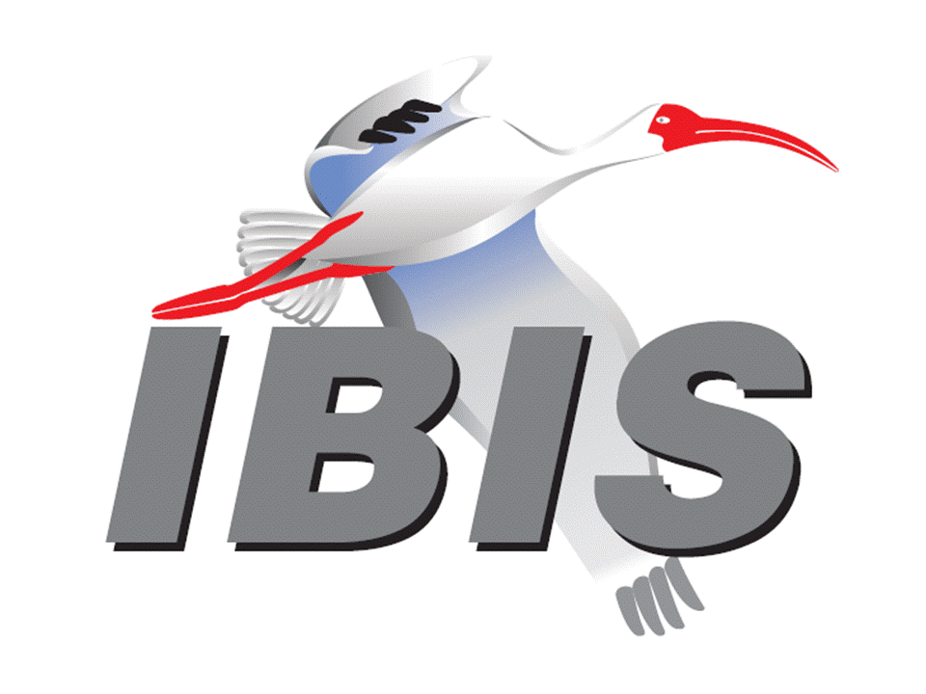
IBIS Open Forum Minutes

Meeting Date: March 14, 2014
Meeting Location: Teleconference

VOTING MEMBERS AND 2014 PARTICIPANTS
Agilent Technologies Radek Biernacki*, Nilesh Kamdar, Colin Warwick,
Graham Riley, Pegah Alavi, Fangyi Rao,
Heidi Barnes
Altera David Banas, Kundan Chand, Hsinho Wu
ANSYS (Steve Pytel)
Applied Simulation Technology Fred Balistreri, Norio Matsui
Cadence Design Systems Ambrish Varma, Brad Brim, Joy Li, Kumar Keshavan,
Ken Willis, Yingxin Sun, Joshua Luo, John Phillips
Ericsson Anders Ekholm, Zilwan Mahmod
Foxconn Technology Group (Sogo Hsu)
Huawei Technologies Jinjun Li, Xiaoqing Dong
IBM Adge Hawes
Infineon Technologies AG (Christian Sporrer)
Intel Corporation Michael Mirmak*, Jon Powell, Riaz Naseer
Udy Shrivastava, Mustafa Yousuf, Jimmy Jackson
IO Methodology Lance Wang, Michelle Coombs
LSI Xingdong Dai, Min Huang, Anaam Ansari, Brian Burdick*
Maxim Integrated Products Hassan Rafat
Mentor Graphics Arpad Muranyi*, John Angulo, Fadi Deek
Micron Technology Randy Wolff*
Signal Integrity Software Mike LaBonte*, Walter Katz*, Todd Westerhoff,
Michael Steinberger
Synopsys Ted Mido, Scott Wedge
Teraspeed Consulting Group Bob Ross*, Tom Dagostino, Scott McMorrow
Toshiba (Yasumasa Kondo)
Xilinx Ravindra Gali
Zuken Michael Schaeder, Amir Wallrabenstein, Griff Derryberry

OTHER PARTICIPANTS IN 2014
ECL Advantage Thomas Iddings
Hewlett Packard Ting Zhu
KEI Systems Shinichi Maeda
Lattice Semiconductor Xu Jiang
Mellanok Technologies Piers Dawe
Pangeya Edgar Aguirre
Proficient Design Kishor Patel
SAE International Chris Denham
Vitesse Siris Tsang

In the list above, attendees at the meeting are indicated by *. Principal members or other active members who have not attended are in parentheses. Participants who no longer are in the organization are in square brackets.

UPCOMING MEETINGS
The bridge numbers for future IBIS teleconferences are as follows:

Date Meeting Number Meeting Password
April 4, 2014 205 475 958 IBIS

For teleconference dial-in information, use the password at the following website:

https://ciscosales.webex.com/ciscosales/j.php?J=205475958

All teleconference meetings are 8:00 a.m. to 9:55 a.m. US Pacific Time. Meeting agendas are typically distributed seven days before each Open Forum. Minutes are typically distributed within seven days of the corresponding meeting. When calling into the meeting, follow the prompts to enter the meeting ID. For new, local international dial-in numbers, please reference the bridge numbers provided by Cisco Systems at the following link:

http://www.cisco.com/web/about/doing_business/conferencing/index.html

NOTE: "AR" = Action Required.

-------------------------------------------------------------------------------------------------------------------------------
INTRODUCTIONS AND MEETING QUORUM
Randy Wolff declared that a quorum was reached and the meeting could begin.

Several attendees noted issues with connecting to WebEx, and at least one attendee was never able to connect.

CALL FOR PATENTS
Michael Mirmak called for any patents or pending patents related to the IBIS 3.2, IBIS 4.2, IBIS 5.1, IBIS 6.0, Touchstone 2.0 or ICM 1.1 specifications. No patents were declared.

REVIEW OF MINUTES AND ARS
Randy Wolff called for comments regarding the minutes of the February 21, 2014 IBIS Open Forum teleconference. The minutes were approved without changes.

ANNOUNCEMENTS
Michael Mirmak announced that he had new IEEE updates to share, and these were already listed on the agenda.

CALL FOR ADDITIONAL AGENDA ITEMS
None.

MEMBERSHIP STATUS AND TREASURER'S REPORT
Bob Ross reported that the treasury sits at $24,181. 11 members have renewed so far for 2014. Bob took an AR to start reminding members of renewals. Michael Mirmak asked if our target is still about 28-30 members. Bob noted that he pushed back on Chris Denham to see if 22 members are enough to break even. We had that many last year. Mike LaBonte asked if the renewal email would have come from SAE. Michael responded that the email was sent from Rita Gerber, and it should have an invoice attached.

WEB PAGE AND MAILING LIST ADMINISTRATION
Mike LaBonte had no web page items to report. Concerning email, one person reached Mike through Lance Wang. Emails from the person were not reaching ibis*@eda.org. Anyone can contact Mike at mike@labonte.com if they are not seeing emails sent to the ibis reflectors go through.

MODEL LIBRARY UPDATE
No update. Mike LaBonte noted that the library was updated recently and all the links were checked for validity.

INTERNATIONAL/EXTERNAL ACTIVITIES
- Conferences
The 18th IEEE Workshop on Signal and Power Integrity (SPI 2014) will be held May 11-14, 2014 in Ghent, Belgium. There will be a European IBIS Summit in conjunction with this conference. There are typically many papers on IBIS-related algorithms presented by student researchers. More information is available at:

http://spi2014.org

- Press Update
None.

- New IEEE Standards
Michael Mirmak reported seeing a press release at the end of February about the formation of IEEE working groups P2401 and P1666. These groups are officially known as the SystemC Analog/Mixed-Signal (AMS) Extensions working group and the LPB – Standard Format for Large Scale Integration (LSI)-Package-Board Interoperable Design working group. Both groups do technical work in EDA standards development. The press release is linked at:

http://www.businesswire.com/news/home/20140226005029/en/IEEE-Forms-Working-Groups-Standardize-Steps-Electronic#.UyMf59XnbvU

Michael also noted that the IEEE P1735 working group that works on encryption is active. They are in the testing and implementation stage of the standard development. Mike LaBonte asked what IBIS’ most recent interest in encryption was. Michael responded that there was a hurdle to IBIS 4.1 AMS language adoption if the model contained IP and couldn’t be encrypted. There was some thought that P1735 could be used with the AMS languages. It could be extended to Spice macromodels potentially. Mike asked if there is anything we’d need to do once the standard is finished. Michael felt that we’d need to see if anything in IBIS 4.1 would need to change to support encryption.

SUMMIT PLANNING AND STATUS
- European IBIS Summit Status
The Summit is scheduled after the SPI event on May 14, 2014 in Ghent, Belgium. The first call for papers will go out next week. Randy Wolff noted that he is planning to attend, so if no other officers can attend, he can run the meeting. Michael Mirmak noted that sponsorships are welcome.

- 2014 Summit schedule
DAC is June 1-5, 2014 in San Francisco, CA. Michael Mirmak contacted DAC organizers to see about potential co-sponsorships with DAC. Most deadlines have passed, but he does have contact information for next year. So, we’ll probably make use of a room reserved by one of our member organizations.

Sponsorship opportunities for all upcoming IBIS summits are available, with sponsors receiving free mentions in the minutes, agenda, and other announcements. Contact the IBIS Board for further details.

QUALITY TASK GROUP
Mike LaBonte reported that there is ongoing activity to finish the ibischk program documentation. He is hoping to complete the document for release along with the next ibischk version. The group is meeting on an as-needed basis during the Tuesdays at 8:00 a.m. PT time slot. If anyone is interested in attending, look for the meeting notices the day before.

The Quality Task Group checklist and other documentation can be found at:

http://www.eda.org/ibis/quality_wip/

ADVANCED TECHNOLOGY MODELING TASK GROUP
Arpad Muranyi reported that the group is meeting regularly on Tuesdays at 12:00 p.m. PT. They are currently discussing BIRD147 on backchannel modeling. There was discussion about starting up an interconnect modeling meeting to have additional time for discussion of package modeling. Bob Ross commented that he is working with Ambrish Varma on the backchannel BIRD and is simplifying it. There will be technical and editorial changes to present at the next meeting. Michael Mirmak asked if there would be additional follow-up to discuss PCI express or other interfaces that require backchannel modeling. Arpad did not have any information about these interfaces. Michael noted that he may have additional experts available to present on these interfaces.

Task group material can be found at:

http://www.eda.org/ibis/macromodel_wip/

NEW ADMINISTRATIVE ISSUES
Michael Mirmak noted that the Interconnect task group will be restarted next week for discussions of package modeling. Let him know if you are interested in attending and were not previously on the task group’s mailing list.

BIRD125.1: MAKE IBIS-ISS AVAILABLE FOR IBIS PACKAGE MODELING
Discussion was tabled.

BIRD128: ALLOW AMI_PARAMETERS_OUT TO PASS AMI_PARAMETERS_IN DATA ON CALLS TO AMI_GETWAVE
Discussion was tabled.

BIRD145.3: CASCADING IBIS I/O BUFFERS WITH [EXTERNAL CIRCUIT]S USING THE [MODEL CALL] KEYWORD
Discussion was tabled.

BIRD147: BACK-CHANNEL SUPPORT
Discussion was tabled.

BIRD157: PARAMETERIZE [DRIVER SCHEDULE]
Discussion was tabled.

BIRD158.3: AMI TOUCHSTONE ANALOG BUFFER MODELS
Discussion was tabled.

BIRD161.1: SUPPORTING INCOMPLETE AND BUFFER-ONLY [COMPONENT] DESCRIPTIONS
Discussion was tabled.

BIRD163: INSTANTIATING AND CONNECTING [EXTERNAL CIRCUIT] PACKAGE MODELS WITH [CIRCUIT CALL]
Discussion was tabled.

BIRD164: ALLOWING PACKAGE MODELS TO BE DEFINED IN [EXTERNAL CIRCUIT]
Discussion was tabled.

BIRD165: PARAMETER PASSING IMPROVEMENTS FOR [EXTERNAL CIRCUIT]S
Discussion was tabled.

IBISCHK5 PARSER AND BUG STATUS
Bob Ross reported there are no new bugs. BUG147, BUG148 and BUG149 will be fixed in the ibischk6 release.

IBISCHK6 PARSER STATUS
Bob Ross reported that the developer has implemented all the BIRDs except BIRD160 so far and is planning to share the code with him. Any paid parser owner is free to look at the code drop.

Bob noted that some issues with IBIS 6.0 have been discussed recently. He requested Michael Mirmak to create a known issues list on the website.

NEW TECHNICAL ISSUES
Michael Mirmak noted that many EDA vendors expressed concerns with the IBIS specification being released every 6 months. He thinks we should discuss going to a one year release schedule instead of a 6 month release schedule.

NEXT MEETING
The next IBIS Open Forum teleconference will be held April 4, 2014 from 8:00 a.m. to 10:00 a.m. US Pacific Time. The following meeting will be held April 25, 2014.

Radek Biernacki moved to adjourn. Arpad Muranyi seconded the motion. There were no objections.

========================================================================
NOTES

IBIS CHAIR: Michael Mirmak (916) 356-4261, Fax (916) 377-3788
michael.mirmak@intel.com
Data Center Platform Applications Engineering
Intel Corporation
FM5-239
1900 Prairie City Rd.,
Folsom, CA 95630

VICE CHAIR: Lance Wang (978) 633-3388
lwang@iometh.com
President/CEO, IO Methodology, Inc.
PO Box 2099
Acton, MA 01720

SECRETARY: Randy Wolff (208) 363-1764, Fax: (208) 368-3475
rrwolff@micron.com
Principal Engineer, Modeling Group Lead, Micron Technology, Inc.
8000 S. Federal Way
Mail Stop: 01-711
Boise, ID 83707-0006

LIBRARIAN: Anders Ekholm (46) 10 714 27 58, Fax: (46) 8 757 23 40
ibis-librarian@eda.org
Digital Modules Design, PDU Base Stations, Ericsson AB
BU Network
Färögatan 6
164 80 Stockholm, Sweden

WEBMASTER: Mike LaBonte
mikelabonte@eda.org
IBIS-AMI Modeling Specialist, Signal Integrity Software
6 Clock Tower Place
Maynard, MA 01754

POSTMASTER: Mike LaBonte
mikelabonte@eda.org
IBIS-AMI Modeling Specialist, Signal Integrity Software
6 Clock Tower Place
Maynard, MA 01754

This meeting was conducted in accordance with ANSI guidance.

The following e-mail addresses are used:

majordomo@eda.org
In the body, for the IBIS Open Forum Reflector:
subscribe ibis <your e-mail address>

In the body, for the IBIS Users' Group Reflector:
subscribe ibis-users <your e-mail address>

Help and other commands:
help

ibis-request@eda.org
To join, change, or drop from either or both:
IBIS Open Forum Reflector (ibis@eda.org)
IBIS Users' Group Reflector (ibis-users@eda.org)
State your request.

ibis-info@eda.org
To obtain general information about IBIS, to ask specific questions for individual response, and to inquire about joining the IBIS Open Forum as a full Member.

ibis@eda.org
To send a message to the general IBIS Open Forum Reflector. This is used mostly for IBIS Standardization business and future IBIS technical enhancements. Job posting information is not permitted.

ibis-users@eda.org
To send a message to the IBIS Users' Group Reflector. This is used mostly for IBIS clarification, current modeling issues, and general user concerns. Job posting information is not permitted.

ibis-bug@eda.org
To report ibischk parser BUGs as well as tschk2 parser BUGs. The BUG Report Form for ibischk resides along with reported BUGs at:

http://www.eda.org/ibis/bugs/ibischk/
http://www.eda.org/ibis/bugs/ibischk/bugform.txt

The BUG Report Form for tschk2 resides along with reported BUGs at:

http://www.eda.org/ibis/tschk_bugs/
http://www.eda.org/ibis/tschk_bugs/bugform.txt

icm-bug@eda.org
To report icmchk1 parser BUGs. The BUG Report Form resides along with reported
BUGs at:

http://www.eda.org/ibis/icm_bugs/
http://www.eda.org/ibis/icm_bugs/icm_bugform.txt

To report s2ibis, s2ibis2 and s2iplt bugs, use the Bug Report Forms which reside at:

http://www.eda.org/ibis/bugs/s2ibis/bugs2i.txt
http://www.eda.org/ibis/bugs/s2ibis2/bugs2i2.txt
http://www.eda.org/ibis/bugs/s2iplt/bugsplt.txt

Information on IBIS technical contents, IBIS participants and actual IBIS models are available on the IBIS Home page:

http://www.eda.org/ibis

Check the IBIS file directory on eda.org for more information on previous discussions and results:

http://www.eda.org/ibis/directory.html

Other trademarks, brands and names are the property of their respective owners.
IBIS – SAE STANDARDS BALLOT VOTING STATUS

I/O Buffer Information Specification Committee (IBIS)
Organization | Interest Category | Standards Ballot Voting Status | January 10, 2014 | January 31, 2014 | February 21, 2014 | March 14, 2014
Agilent Technologies | User | Active | X | X | X | X
Altera | Producer | Active | - | X | X | -
ANSYS | User | Inactive | - | - | - | -
Applied Simulation Technology | User | Inactive | - | X | - | -
Cadence Design Systems | User | Active | X | X | X | -
Ericsson | Producer | Inactive | - | X | - | -
Foxconn Technology Group | Producer | Inactive | - | - | - | -
Huawei Technologies | Producer | Inactive | - | X | - | -
IBM | Producer | Active | X | X | X | -
Infineon Technologies AG | Producer | Inactive | - | - | - | -
Intel Corp. | Producer | Active | X | X | X | X
IO Methodology | User | Active | X | X | X | -
LSI | Producer | Inactive | X | - | X | X
Maxim Integrated Products | Producer | Inactive | - | X | - | -
Mentor Graphics | User | Active | X | X | X | X
Micron Technology | Producer | Active | X | X | X | X
Signal Integrity Software | User | Active | X | X | X | X
Synopsys | User | Inactive | - | X | - | -
Teraspeed Consulting | General Interest | Active | X | X | X | X
Toshiba | Producer | Inactive | - | - | - | -
Xilinx | Producer | Inactive | - | X | - | -
Zuken | User | Inactive | - | X | - | -

Criteria for Member in good standing:
- Must attend two consecutive meetings to establish voting membership
- Membership dues current
- Must not miss two consecutive Meetings
Interest categories associated with SAE ballot voting are:
- Users - Members that utilize electronic equipment to provide services to an end user.
- Producers - Members that supply electronic equipment.
- General Interest - Members are neither producers nor users. This category includes, but is not limited to, Government, regulatory agencies (state and federal), researchers, other organizations and associations, and/or consumers.

