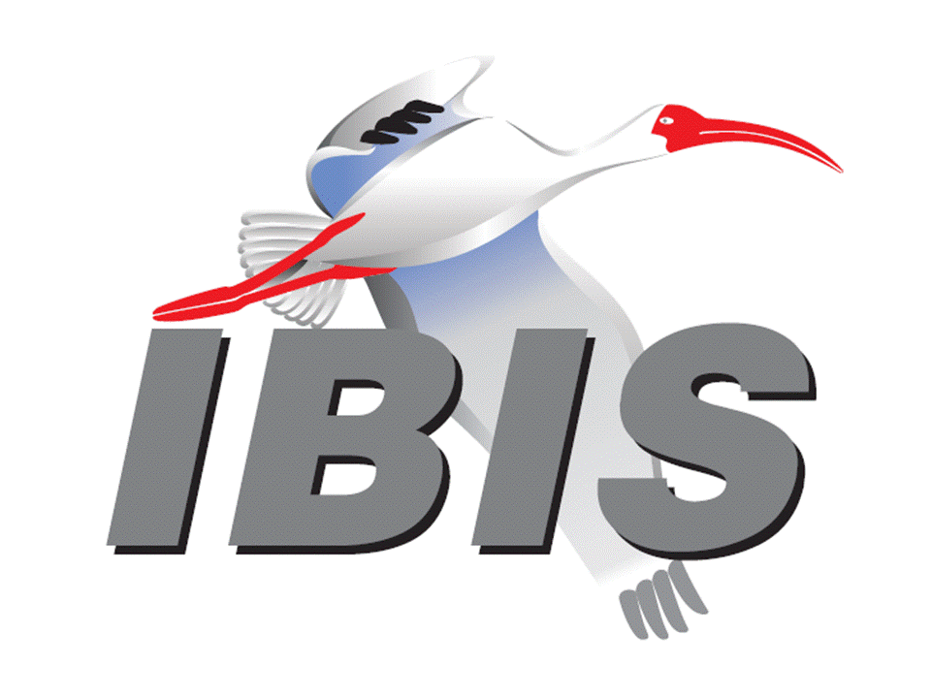

IBIS Open Forum Minutes

Meeting Date: March 23, 2018
Meeting Location: Teleconference

VOTING MEMBERS AND 2018 PARTICIPANTS
ANSYS Curtis Clark*
Applied Simulation Technology (Fred Balistreri)
Broadcom (Yunong Gan)
Cadence Design Systems Brad Brim, Ken Willis, Ambrish Varma*
Cisco Systems Stephen Scearce, Cassie Yan, Baosh Xu
CST Stefan Paret
Ericsson Anders Ekholm, Zilwan Mahmod, Guohua Wang
GLOBALFOUNDRIES Steve Parker
Huawei Technologies (Hang (Paul) Yan)
IBM Greg Edlund
Infineon Technologies AG (Christian Sporrer)
Intel Corporation Hsinho Wu, Michael Mirmak*, Nilesh Dattani
Fernando Mendoza Hernandez, Varun Gupta
Subas Bastola, Hansel Dsilva
IO Methodology Lance Wang*
Keysight Technologies Radek Biernacki*, Ming Yan, Heidi Barnes
Pegah Alavi
Maxim Integrated Joe Engert, Yan Liang
Mentor, A Siemens Business Arpad Muranyi*, Weston Beal, Raj Raghuram
Carlo Bleu, Mikael Stahlberg, Yasushi Kondou
Vladimir Dmitriev-Zdorov
Micron Technology Randy Wolff*, Justin Butterfield
NXP (John Burnett)
Qualcomm Kevin Roselle, Tim Michalka
Raytheon Joseph Aday
SiSoft Mike LaBonte*, Walter Katz*, Todd Westerhoff
Synopsys Ted Mido*, Adrien Auge, Scott Wedge
Teraspeed Labs Bob Ross*
Xilinx Ravindra Gali
ZTE Corporation (Shunlin Zhu)
Zuken Michael Schaeder, Takayuki Shiratori

OTHER PARTICIPANTS IN 2018
Google Zhiping Yang
Haskware David Banas
John Baprawski, Inc. John Baprawski
KEI Systems Shinichi Maeda
Lattice Semiconductor Dinh Tran, Maryam Shahbazi
OmniVision Sirius Tsang
Ricoh Kazuki Murata
RITA Electronics Ltd. Kenichi Higashiura, Hiroyuki Motoki
SAE-ITC (Jose Godoy)
Signal Metrics Ron Olisar
Socionext Megumi Ono
SPISim Wei-hsing Huang
Stanford University Tom Lee
Toshiba Yasuki Torigoshi, Yoshinori Fukuba

In the list above, attendees at the meeting are indicated by *. Principal members or other active members who have not attended are in parentheses. Participants who no longer are in the organization are in square brackets.

UPCOMING MEETINGS
The bridge numbers for future IBIS teleconferences are as follows:

Date Meeting Number Meeting Password
April 13, 2018 624 227 121 IBISfriday11

For teleconference dial-in information, use the password at the following website:

http://tinyurl.com/y7yt7buz

All teleconference meetings are 8:00 a.m. to 9:55 a.m. US Pacific Time. Meeting agendas are typically distributed seven days before each Open Forum. Minutes are typically distributed within seven days of the corresponding meeting.

NOTE: "AR" = Action Required.

-------------------------------------------------------------------------------------------------------------------------------
INTRODUCTIONS AND MEETING QUORUM
Mike LaBonte declared that a quorum was reached and the meeting could begin.

CALL FOR PATENTS
Mike LaBonte called for declaration of any patents or pending patents related to the IBIS 3.2, IBIS 4.2, IBIS 5.1, IBIS 6.1, Touchstone 2.0, IBIS-ISS 1.0 or ICM 1.1 specifications. No patents were declared.

REVIEW OF MINUTES AND ARS
Mike LaBonte called for comments on the minutes of the March 9, 2018 IBIS Open Forum teleconference. Curtis Clark moved to approve the minutes. Bob Ross seconded the motion. There were no objections.

There were no ARs to review.

ANNOUNCEMENTS, CALL FOR ADDITIONAL AGENDA ITEMS
Mike LaBonte noted he sent the meeting agenda out late for this meeting.

MEMBERSHIP STATUS AND TREASURER'S REPORT
Bob Ross reported that we are at 26 members. There have been 13 renewals for 2018 so far. There is $8,415 in the treasury. We are working on a new format for reporting numbers per SAE’s request for breaking down expenses. They are requesting budget information that Bob is working to provide. We had a meeting with SAE last Wednesday including Jose Godoy and Laurie Strom, the VP of the group under which we are positioned. They are working on an SAE-ITC landing spot on their webpage for IBIS and other committees that report into SAE-ITC. We provided some input on that.

WEBSITE ADMINISTRATION
Mike LaBonte reported there have been no major changes to the website. Bob mentioned the most recent meeting with SAE and the fact that they are saying later this year they are hoping to build a landing page for it, but not replace our website. IBIS is one of several standards organizations under SAE-ITC. They showed us the ARINC landing page as an example. It would have, for example, links to become a member. Clicking on things would take you to our regular webpage.

MAILING LIST ADMINISTRATION
Curtis Clark reported nothing new to report. Everything is running smoothly.

LIBRARY UPDATE
None.

INTERNATIONAL/EXTERNAL ACTIVITIES
- Conferences
SPI2018 – the 22nd IEEE Workshop on Signal and Power Integrity will be held in Brest, France on May 22-25, 2018. An IBIS Summit will be held after the event. More information is available at:

https://spi2018.sciencesconf.org/

Ambrish Varma reported that he attended the DesignCon planning meeting for 2019. There was some talk of organizing a track for IBIS. Mike LaBonte added that he first heard this suggested a few years ago. Walter Katz strongly suggested they do have a separate track, as there were many IBIS-AMI papers at the same time during the show in 2018. Ambrish noted that many other tracks cover high speed simulation and other IBIS related topics. He asked when do we want a track just for IBIS. The main advantage for IBIS is to not have overlapping papers as Walter mentioned. Randy Wolff added that there are several IBIS members on the technical program committee, so we would just need a common direction if we want to recommend or organize this. Walter felt there could be something like IBIS-AMI and equalization as a track topic, since this would also cover DDR5. Randy motioned to discuss this further and bring a recommendation to DesignCon in the next few weeks. Michael seconded the motion. There were no objections.

- Press Update
None.

- Related standards
IEC 63055/IEEE 2401, JEITA “LPB”

Michael Mirmak reported that on February 1, there was a DASC meeting at DVCON. Michael met with a couple members of DASC. He had positive discussions with the board membership who wanted to see IBIS join DASC. IEEE 2401 is starting work and anticipates resuming meetings in April to take up more LPB work. Tanaka-san will participate more in IBIS meetings. They would like to have discussion on how IBIS can participate more generally in DASC and 2401, including how IBIS could become an entity member of DASC. Bob Ross mentioned we may have another board meeting discussing these topics with some IEEE members.

SUMMIT PLANNING AND STATUS
- European IBIS Summit at SPI 2018
SPI 2018 will be held in Brest, France on May 22 through May 25, 2018. An IBIS Summit will be held the afternoon of Friday, May 25, 2018. Mike LaBonte will be attending. The SPI program is now published. Bob Ross noted the schedule currently is to start at 1:30 p.m. Mike noted that the first announcement needs to go out. Zuken is a sponsor.

Sponsorship opportunities for all upcoming IBIS summits are available, with sponsors receiving free mentions in the minutes, agenda, and other announcements. Contact the IBIS Board for further details.

QUALITY TASK GROUP
Mike LaBonte reported that the group is meeting on Tuesdays at 8:00 a.m. PT. The focus remains about IBISCHK bugs. Recently there is some advanced work to prepare the parser development contract, at least the technical requirements portion of it.

The IBISCHK6 user guide work in progress can be reviewed at:

http://www.ibis.org/ibischk6/ibischk_6.1.4_UserGuide_wip1.pdf

The Quality task group checklist and other documentation can be found at:

http://www.ibis.org/quality_wip/

ADVANCED TECHNOLOGY MODELING TASK GROUP
Arpad Muranyi reported that the group is meeting regularly on Tuesdays at 12:00 p.m. PT. The group has been trying to help the progress of BIRD189 and BIRD158. The primary focus is BIRD158 to ensure it is compatible with BIRD189.

Task group material can be found at:

http://www.ibis.org/macromodel_wip/

INTERCONNECT TASK GROUP
Michael Mirmak reported that the group is meeting at 8:00 a.m. PT on Wednesdays. The Friday Editorial task group time slot is also used on occasion. BIRD189 is the singular focus. There has been a lot of recent activity on the reflectors about A_gnd, or Node 0, and whether it should be made available to model makers in the specification. Join in the discussion if you have any strong opinions about it. There should be some motions to close this out soon and prepare a BIRD draft for submittal to the Open Forum.

Task group material can be found at:

http://www.ibis.org/interconnect_wip/

EDITORIAL TASK GROUP
Mike LaBonte reported that this group remains suspended. Should there be any official document to review such as IBIS 7.0, the task group will resume meetings on Fridays when there is no Open Forum teleconference.

Task group material can be found at:

http://www.ibis.org/editorial_wip/

NEW ADMINISTRATIVE ISSUES
Mike LaBonte thanked both Arpad Muranyi and Michael Mirmak for their continued service as chairs of the Interconnect and ATM task groups.

BIRD193: FIGURE 29 CORRECTIONS
Arpad Muranyi noted the BIRD fixes Figure 29 and surrounding examples. For several years, there have been forward looking ideas in the figure related to package modeling capabilities. Now that BIRD189 is almost ready, we did not want drawings and examples that will not be supported in the specification. This BIRD cleans up the specification and makes it compatible with the BIRD189 features.

Arpad moved to vote on approval of BIRD193. Michael Mirmak seconded the motion. There were no objections.

The roll call vote tally was:

ANSYS – yes
Cadence – abstain
Intel – yes
IO Methodology – yes
Keysight – yes
Mentor – yes
Micron – yes
SiSoft – yes
Synopsys – yes
Teraspeed Labs – yes

The roll call vote concluded with a vote tally of Yes – 9, No – 0, Abstain – 1. The vote passed.

Mike LaBonte will update the web with the BIRD vote changes [AR].

BIRD125.1: MAKE IBIS-ISS AVAILABLE FOR IBIS PACKAGE MODELING
Discussion was tabled.

BIRD145.3: CASCADING IBIS I/O BUFFERS WITH [EXTERNAL CIRCUIT]S USING THE [MODEL CALL] KEYWORD
Discussion was tabled.

BIRD163: INSTANTIATING AND CONNECTING [EXTERNAL CIRCUIT] PACKAGE MODELS WITH [CIRCUIT CALL]
Discussion was tabled.

BIRD164: ALLOWING PACKAGE MODELS TO BE DEFINED IN [EXTERNAL CIRCUIT]
Discussion was tabled.

BIRD166.4: RESOLVING PROBLEMS WITH REDRIVER INIT FLOW
Discussion was tabled.

BIRD181.1: I-V TABLE CLARIFICATIONS
Discussion was tabled.

BIRD189.4: INTERCONNECT MODELING USING IBIS-ISS AND TOUCHSTONE
Discussion was tabled.

BIRD190: CLARIFICATION FOR REDRIVER FLOW
Discussion was tabled.

IBISCHK PARSER AND BUG STATUS
Bob Ross reported no further update. The parser contract is being worked on slowly in the Quality task group by specifying what is expected by each BIRD.

Bob noted that there is an issue with BIRD158.7 where there is a parameter value that does not specify if it should be greater than 0 or just a positive number. It would have come up in the Touchstone S-parameter BIRD, but receiver terminations must be greater than zero, otherwise there is no waveform to be processed by the internal executable model. Mike LaBonte noted the specification does say related to Rx_R that there would be an error if it was not a valid float number. Bob and Mike think they need to warn if there are negative numbers for this parameter, but this does not exclude Rx_R of 0, since the specification does not state that the value of 0 is not valid. Bob thinks the BIRD may need to state that Rx_R cannot be 0.

Arpad Muranyi noted the model is always in series, looking at the waveform at the pad or core side nodes, not at the pin. Bob said that with a value of 0, the AMI model would be driven with 0 volts. Arpad agreed this item should be included in an update to BIRD158 or the replacement BIRD for BIRD158. Radek Biernacki noted a warning is appropriate at this time based on BIRD158. Arpad thought the specification could be fixed since a replacement BIRD for BIRD158 is in progress. Arpad noted the issue can be discussed further in the ATM meeting.

Mike posed the question about where we allow 0 and do not allow a value of 0. In the table of classifications for ibischk, there is a warning of Tx_V equal to 0, since this is a dead transmitter. Should we really warn about this? Radek noted this is fine since it is just a warning. Mike asked if we should be consistent about a shorted Rx_R, which is indicating a defective Rx. For now, the instruction is to warn about Rx_R of 0, but it would be best to be explicit about the values permitted in the BIRD, so the parser could issue errors.

NEW TECHNICAL ISSUES
None.

NEXT MEETING
The next IBIS Open Forum teleconference meeting will be held on April 13, 2018. The following IBIS Open Forum teleconference meeting is tentatively scheduled on May 4, 2018.

Arpad Muranyi moved to adjourn. Bob Ross seconded the motion. The meeting adjourned.

========================================================================
NOTES

IBIS CHAIR: Mike LaBonte
mlabonte@sisoft.com
IBIS-AMI Modeling Specialist, SiSoft
6 Clock Tower Place, Suite 250
Maynard, MA 01754

VICE CHAIR: Lance Wang (978) 633-3388
lwang@iometh.com
President/CEO, IO Methodology, Inc.
PO Box 2099
Acton, MA 01720

SECRETARY: Randy Wolff (208) 363-1764
rrwolff@micron.com
Principal Engineer, Silicon SI Group Lead, Micron Technology, Inc.
8000 S. Federal Way
P.O. Box 6, Mail Stop: 01-711
Boise, ID 83707-0006

TREASURER: Bob Ross (503) 246-8048
bob@teraspeedlabs.com
Engineer, Teraspeed Labs
10238 SW Lancaster Road
Portland, OR 97219

LIBRARIAN: Anders Ekholm (46) 10 714 27 58, Fax: (46) 8 757 23 40
ibis-librarian@ibis.org
Digital Modules Design, PDU Base Stations, Ericsson AB
BU Network
Färögatan 6
164 80 Stockholm, Sweden

WEBMASTER: Mike LaBonte
mlabonte@sisoft.com
IBIS-AMI Modeling Specialist, SiSoft
6 Clock Tower Place, Suite 250
Maynard, MA 01754

POSTMASTER: Curtis Clark
curtis.clark@ansys.com
ANSYS, Inc.
150 Baker Ave Ext
Concord, MA 01742

This meeting was conducted in accordance with ANSI guidance.

All inquiries may be sent to info@ibis.org. Examples of inquiries are:
- To obtain general information about IBIS.
- To ask specific questions for individual response.
- To subscribe to the official ibis@freelists.org and/or ibis-users@freelists.org email lists (formerly ibis@eda.org and ibis-users@eda.org).
- To subscribe to one of the task group email lists: ibis-macro@freelists.org, ibis-interconn@freelists.org, or ibis-quality@freelists.org.
- To inquire about joining the IBIS Open Forum as a voting Member.
- To purchase a license for the IBIS parser source code.
- To report bugs or request enhancements to the free software tools: ibischk6, tschk2, icmchk1, s2ibis, s2ibis2 and s2iplt.
The BUG Report Form for ibischk resides along with reported BUGs at:

http://www.ibis.org/bugs/ibischk/
http://www.ibis.org/ bugs/ibischk/bugform.txt

The BUG Report Form for tschk2 resides along with reported BUGs at:

http://www.ibis.org/bugs/tschk/
http://www.ibis.org/bugs/tschk/bugform.txt

The BUG Report Form for icmchk resides along with reported BUGs at:

http://www.ibis.org/bugs/icmchk/
http://www.ibis.org/bugs/icmchk/icm_bugform.txt

To report s2ibis, s2ibis2 and s2iplt bugs, use the Bug Report Forms which reside at:

http://www.ibis.org/bugs/s2ibis/bugs2i.txt
http://www.ibis.org/bugs/s2ibis2/bugs2i2.txt
http://www.ibis.org/bugs/s2iplt/bugsplt.txt

Information on IBIS technical contents, IBIS participants and actual IBIS models are available on the IBIS Home page:

http://www.ibis.org/

Check the IBIS file directory on ibis.org for more information on previous discussions and results:

http://www.ibis.org/directory.html

Other trademarks, brands and names are the property of their respective owners.
SAE STANDARDS BALLOT VOTING STATUS
Organization | Interest Category | Standards Ballot Voting Status | February 2, 2018 | February 16, 2018 | March 9, 2018 | March 23, 2018
ANSYS | User | Active | - | X | X | X
Applied Simulation Technology | User | Inactive | - | - | - | -
Broadcom Ltd. | Producer | Inactive | - | - | - | -
Cadence Design Systems | User | Inactive | X | - | - | X
Cisco Systems | User | Inactive | X | - | - | -
CST | User | Inactive | X | - | - | -
Ericsson | Producer | Inactive | X | - | - | -
GLOBALFOUNDRIES | Producer | Active | X | X | X | -
Huawei Technologies | Producer | Inactive | - | - | - | -
IBM | Producer | Inactive | X | - | - | -
Infineon Technologies AG | Producer | Inactive | - | - | - | -
Intel Corp. | Producer | Active | X | X | X | X
IO Methodology | User | Active | X | X | - | X
Keysight Technologies | User | Active | X | X | X | X
Maxim Integrated | Producer | Inactive | X | - | - | -
Mentor, A Siemens Business | User | Active | X | - | X | X
Micron Technology | Producer | Active | X | X | X | X
NXP | Producer | Inactive | - | - | - | -
Qualcomm | Producer | Inactive | X | - | - | -
Raytheon | User | Inactive | X | - | - | -
SiSoft | User | Active | X | X | X | X
Synopsys | User | Active | X | X | X | X
Teraspeed Labs | General Interest | Active | X | X | X | X
Xilinx | Producer | Inactive | X | - | - | -
ZTE Corp. | User | Inactive | - | - | - | -
Zuken | User | Inactive | X | - | - | -

Criteria for SAE member in good standing:
- Must attend two consecutive meetings to establish voting membership
- Membership dues current
- Must not miss two consecutive meetings
Interest categories associated with SAE standards ballot voting are:
- Users - members that utilize electronic equipment to provide services to an end user.
- Producers - members that supply electronic equipment.
- General Interest - members are neither producers nor users. This category includes, but is not limited to, government, regulatory agencies (state and federal), researchers, other organizations and associations, and/or consumers.

