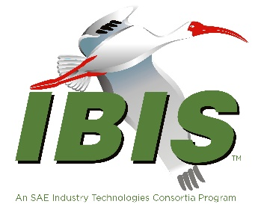
IBIS Hybrid Summit with DesignCon 2026
February 27, 2026
Agenda
All times PST
8:00 AM | SIGN IN AND BREAKFAST BUFFET  Food available at 7:30 AM
8:30 AM | Welcome  Douglas Burns (SI-Clarity)  (Chair, IBIS Open Forum)
8:35 AM | IBIS Chair’s Report  Douglas Burns (SI-Clarity)  (Chair, IBIS Open Forum)
8:55 AM | IBIS-ATM Task Group Report  Arpad Muranyi (Siemens EDA)  Chair, IBIS-ATM Task Group
9:15 AM | IBIS Power Integrity BIRDs: PIM BIRD and Updated BIRD223.1  Walter Katz (MathWorks)
9:45 AM | Accelerating IBIS & Touchstone Specification Feature Development with ANTLR  Michael Mirmak (Intel)
10:15 AM | BREAK (30 minutes)
10:45 AM | Multi-Agent AI Systems for PCB & Package Design and Validation  Alex Manukovsky (Intel)  Joshua Nutzati (Intel)  Yuriy Shlepnev (Simberian)  Shweta Pujari (MathWorks)  Barry Katz (MathWorks)  [Presented by: Alex Manukovsky & Joshua Nutzati]
11:30 AM | Bridging the Gap Between Channel Operating Margin (COM) & IBIS-AMI for Analysis & Development of High-Speed SerDes Designs  Graham Kus (Signal Edge Solutions)
12:00 PM | FREE LUNCH, NETWORKING
1:30 PM | IBIS-AMI Modelling Methodology for Simultaneous Bi-Directional (SBD) Die-to-Die Chiplet Connectivity  Arpit Kothari (Eliyan)  Mohammad Mahani (Eliyan)  Ali Khoshniat (Eliyan)
2:00 PM | IBIS-AMI Modeling for Bi-directional D2D Links with Clock Forwarding & Echo Cancellation  Steven Parker (Marvell)  David Banas (Keysight)  Fangyi Rao (Keysight)  Foad Arvani (Marvell)  Mathew Kelly (Marvell)  John Ma (Marvell)  Reza Mirzaei Nejad (Marvell)  Davide Visani (Marvell)
2:30 PM | OPEN DISCUSSION
2:50 PM | CLOSING REMARKS  Next IBIS Open Forum Meeting Friday, March 20, 2026
3:00 PM | END OF MEETING
 | 