AGENDA - Asian IBIS Summit (Shanghai)
Wednesday, November 14, 2018

Parkyard Hotel Shanghai
Shanghai, P.R. China

Room: Ballroom ABC
Sponsors: Huawei Technologies (Primary)
IO Methodology
Mentor, a Siemens Business
Synopsys
Teledyne LeCroy
ZTE Corporation
(Order and times subject to change)
09:00 SIGN IN
Vendor Tables Open at 9:00
09:30 MEETING WELCOMES
- Yan, Hang (Paul)
(Huawei Technologies, PRC)
- LaBonte, Mike (Chair, IBIS Open Forum)
(SiSoft, USA)
09:40 IBIS Update
LaBonte, Mike (SiSoft, USA)
09:55 How to Fix DDR4 Signal Integrity Issue about "Pin" and "Die"
Meng, Liqiang; Zhu, Shunlin (ZTE Corporation, PRC)
[Presented by Meng, Liqiang, (ZTE Corporation, PRC)]
10:25 BREAK
- Refreshments and Vendor Tables
- Reconvene at 15:40
10:45 Model Correlation for IBIS-AMI
Xie*, Wenyan; Wang*, Guohua; Zhang*, David; Ekholm**; Anders
(Ericsson, *PRC, **Sweden)
[Presented by Xie, Wenyan (Ericsson, PRC)]
11:35 SI Test and Simulation Correlation of 56G PAM4 Eye Diagram for 400G Switch
Shi, Bowen; Feng, Sophia (Celestica, PRC)
[Presented by Shi, Bowen (Celestica, PRC)]
12:00 FREE BUFFET LUNCH (hosted by sponsors)
- Reconvene at 13:30
13:30 A Practical Methodology for SerDes Design
Zhang*, Amy; Wang*, Guohua; Zhang*, David;
Mahmod**, Zilwan; Ekholm**, Anders
(Ericsson, *PRC, **Sweden)
Presented by Mahmod, Zilwan (Ericson, Sweden)]
14:00 Study of DDR Asymmetric Rt/Ft in Existing IBIS-AMI Flow
Huang*, Wei-hsing; Shih**, Wei-kai
(SPISim, *USA, **Japan)
[Presented by Huang, Wei-hsing (SPISim, USA)]
14:30 BREAK
- Reconvene at 14:50
14:50 Characterizing and Modeling of a Clamped Non-Linear CTE/AGC
Liang, Skipper (Cadence Design Systems, ROC)
15:40 DISCUSSION
16:00 CONCLUDING ITEMS
16:10 END OF IBIS SUMMIT MEETING
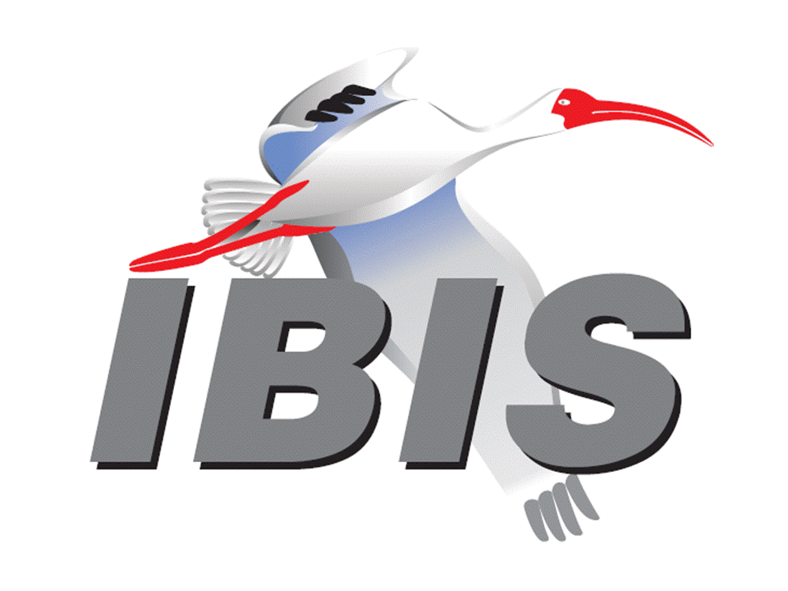
- Thank you for your participation

