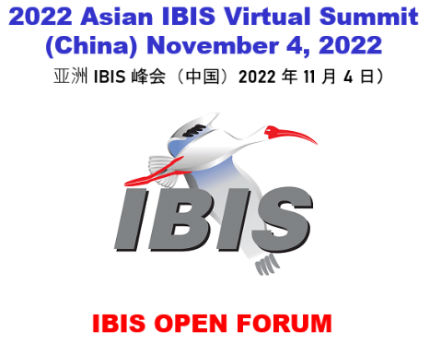
Virtual Asian IBIS Summit (PRC)
Friday, November 4, 2022

Agenda

Room: (Virtual)
Sponsors: IBIS Open Forum
Note: some presentations are tagged [UPLOADED, NON-VERBAL]. This means that the presentation is available to view but will not be presented as part of this program due to time constraints.
(Order and times in CST subject to change)
Summit Recording (MP4)
Minutes
9:00 SIGN IN
9:05 MEETING WELCOME
WOLFF, Randy (Chair, IBIS Open Forum, Micron Technology, USA)
9:10 IBIS Chair's Report
WOLFF, Randy (Micron Technology, USA)
9:15 SPIM (Standard PI Model) in IBIS [UPLOADED, NON-VERBAL]
CAI, Kinger (Intel Corp., USA)
CHEN, Chi-te (Intel Corp., USA)
9:15 IBIS Model Simulation Accuracy Improvement by Including PSIJ Effect
DING, Yifan (Missouri University of Science and Technology, USA)
SUN, Yin (Zhejiang Lab, PRC)
WOLFF, Randy (Micron Technology, USA)
YANG, Zhiping (Waymo, USA)
HWANG, Chulsoon (Missouri University of Science and Technology, USA)
[Presented by DING, Yifan (Missouri University of Science and Technology, USA)]
9:35 [PSIJ Sensitivity] in IBIS
CAI, Kinger (Intel Corp., USA)
TAN, Fern Nee (Intel Corp., USA)
CHEN, Chi-te (Intel Corp., USA)
[Presented by CAI, Kinger (Intel Corp. USA)
10:05 Using IBIS-AMI for DDR5 Applications
HE, Wei (Xpeedic, PRC)
XIA, Jianfeng (Xpeedic, PRC)
DAN, Yufeng (Xpeedic, PRC)
ZHANG, Junwei (Xpeedic, PRC)
SU, Zhouxiang (Xpeedic, PRC).
[Presented by HE, Wei (Xpeedic, PRC)]
10:35 BREAK (10 minutes)
10:45 112G SerDes Signal Simulation and Verification
HUANG, Jian (ZTE Corporation, PRC)
ZHU, Daishan (ZTE Corporation, PRC)
YANG, Zhiwei (ZTE Corporation, PRC)
[Presented by HUANG, Jian (ZTE Corporation, PRC)]
11:05 Bandwidth Analysis of 224 Gb/s Serial Links
ZHENG, Ming (ZTE Corporation, PRC)
YIN, Changgang (ZTE Corporation, PRC)
[Presented by ZHENG, Ming (ZTE Corporation, PRC)]
11:25 AI on SI: Data Efficient Analysis and Manufacturing Process Variation Analysis
LEI, Peizhi (University of Electronic Science and Technology of China [UESTC], PRC)
WANG, Cong (University of Electronic Science and Technology of China [UESTC], PRC)
ZHENG, Jie (University of Electronic Science and Technology of China [UESTC], PRC)
CHEN, Jienan (University of Electronic Science and Technology of China [UESTC], PRC)
LEI, Yiran (Huawei Technologies Co., PRC)
LI, Su (Huawei Technologies Co., PRC)
[Presented by LI, Su (Huawei Technologies Co., PRC)]
11:50 K.T. Wang (Wang Algebra) [UPLOADED, NON-VERBAL]
ROSS, Bob (Teraspeed Labs, USA)
LING, Cong (Imperial College, UK)
11:50 DISCUSSION AND CONCLUDING ITEMS
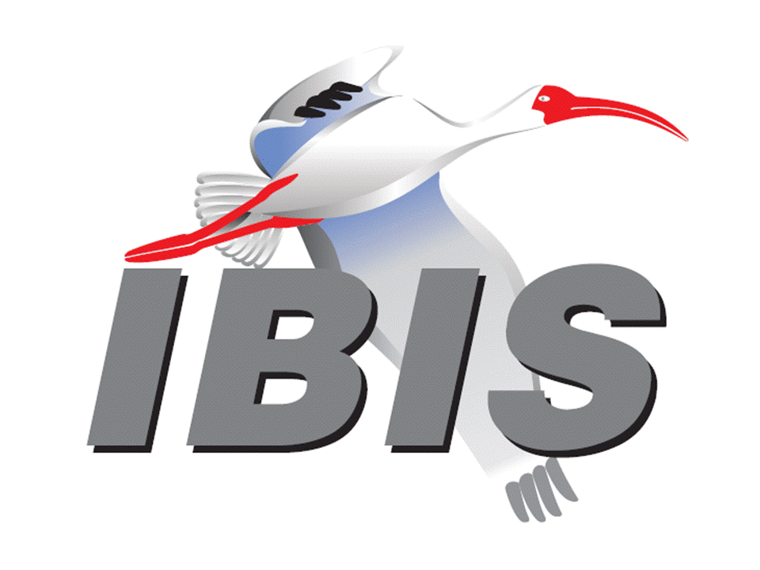
12:00 END OF IBIS SUMMIT MEETING

