BUFFER ISSUE RESOLUTION DOCUMENT (BIRD)

BIRD NUMBER: 233
ISSUE TITLE: AMI Ts2file Analog Model for Single-ended Buffers
REQUESTOR: Adrien Auge, Alphawave Semi;
Fangyi Rao, Ming Yan, Keysight Technologies
DATE SUBMITTED: January 6, 2026
DATE REVISED:
DATE ACCEPTED: February 6, 2026

DEFINITION OF THE ISSUE:
Currently, the analog parts of differential AMI models are modeled either by legacy IBIS models or Touchstone S-parameter models using the Ts4file AMI parameter. The Ts4file parameter can only define S-parameter models for differential buffers. There is a need for a corresponding Ts2file definition for single ended AMI buffer models. To this end, a new reserved AMI parameter Ts2file is introduced. The proposed Ts2file parameter can make use of the existing reserved parameters Tx_V, Tx_R and Rx_R to define the I/O analog circuit.

SOLUTION REQUIREMENTS:
The IBIS specification must meet these requirements:
Table 1: Solution Requirements
Requirement | Notes
Support Touchstone representation of AMI analog model of single-ended buffer

PROPOSED CHANGES:
On page 319, in section 10.10, change sentence

The approach uses 4-port analog circuit data provided in a Touchstone file specified by the AMI parameter named Ts4file (note: Ts4file implies a restricted Touchstone format, where the number of ports is four and the port numbering is predefined).

to

The approach uses 4-port (for differential buffer) or 2-port (for single-ended buffer) analog circuit data provided in a Touchstone file specified by the AMI parameter named Ts4file or Ts2file (note: Ts4file and Ts2file imply a restricted Touchstone format, where the numbers of ports are four and two, respectively, and the port numbering is predefined). Ts4file shall only be used for differential buffers, and Ts2file shall only be used for single-ended buffers.

On page 319, in section 10.10.1, replace Figure 46 with

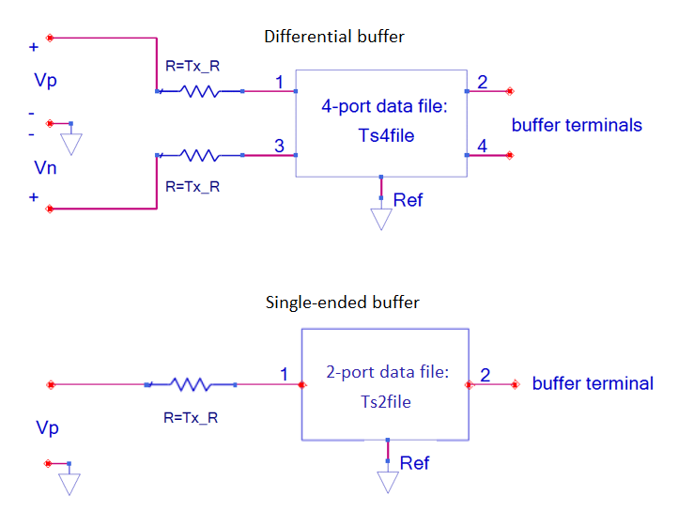

On page 319, in section 10.10.1, change “For logic level 1,” to “In a differential buffer, for logic level 1,”

On page 319, in section 10.10.1, after paragraph

Ports 1, 2, 3 and 4 of the 4-port network are between the nodes 1, 2, 3 and 4 and the common reference node Ref, respectively. For the default port ordering, ports 1 and 3 are at the stimulus source side, and ports 2 and 4 are the transmitter analog buffer model’s output. Furthermore, for the default port ordering, ports 1 and 2 correspond to the non-inverting signal path and ports 3 and 4 to the inverting signal path. The reference node, represented by the triangle reference symbol in Figure 46, is the reference node A_gnd as defined in this specification.

add the following paragraphs.

In a single-ended buffer, for logic level 1, Vp=Tx_V. For logic level 0, Vp=0. The ideal step stimulus is a single-ended voltage waveform Vp when the logic level is switched from 0 to 1. This may be used to determine the impulse response and DC_Offset needed for the AMI flow. For Tx models that have the Reserved Parameter Ts2file, the Reserved Parameter Tx_V is required, and the Reserved Parameter Tx_R is optional (default is 0.0 ohm). For a Tx buffer, the transmitter circuit defines the analog buffer model between the zero-impedance stimulus input voltage source and the buffer terminal.
Ports 1 and 2 of the 2-port network are between nodes 1 and 2 and the common reference node Ref, respectively. Port 1 is at the stimulus source side, and port 2 is the transmitter analog buffer model’s output. The reference node, represented by the triangle reference symbol in Figure 46, is the reference node A_gnd as defined in this specification.

On page 320, in section 10.10.2, replace Figure 47 with

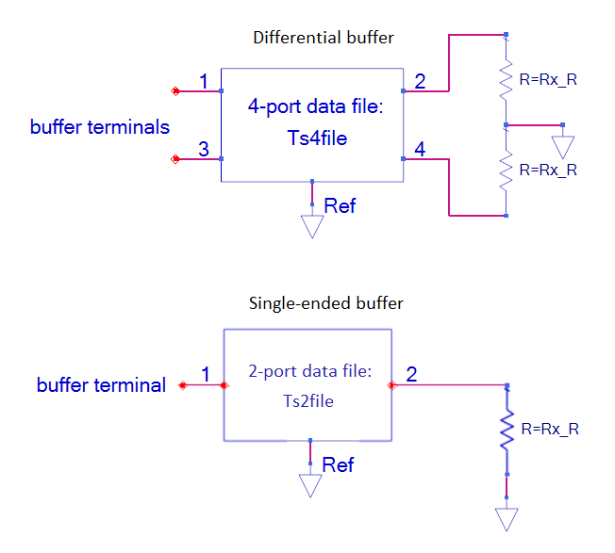
On page 320, in section 10.10.2, replace paragraph

Ports 1, 2, 3 and 4 of the 4-port network are between the nodes 1, 2, 3 and 4 and the common reference node Ref, respectively. For the default port ordering, ports 1 and 3 are the receiver analog buffer model’s input, and the waveforms at ports 2 and 4 are the differential input of the Rx algorithmic model. Furthermore, for the default port ordering, ports 1 and 2 correspond to the non-inverting signal path and ports 3 and 4 to the inverting signal path. The reference node, represented by the triangle reference symbol in Figure 47, is the reference node A_gnd as defined in this specification. For Rx models that have the Reserved Parameter Ts4file, the Reserved Parameter Rx_R is optional (default is open circuit). For an Rx buffer, the receiver circuit defines the analog buffer model between the buffer terminals and the high impedance input of the Rx Algorithmic model.

with

In a differential buffer, ports 1, 2, 3 and 4 of the 4-port network are between the nodes 1, 2, 3 and 4 and the common reference node Ref, respectively. For the default port ordering, ports 1 and 3 are the receiver analog buffer model’s input, and the waveforms at ports 2 and 4 are the differential input of the Rx algorithmic model. Furthermore, for the default port ordering, ports 1 and 2 correspond to the non-inverting signal path and ports 3 and 4 to the inverting signal path. The reference node, represented by the triangle reference symbol in Figure 47, is the reference node A_gnd as defined in this specification. In a single-ended buffer, ports 1 and 2 of the 2-port network are between nodes 1 and 2 and the common reference node Ref, respectively. Port 1 is the receiver analog buffer model’s input. The EDA tool subtracts DC_Offset from the waveform at port 2 and uses the resulting waveform as the single-ended input of the Rx algorithmic model. For Rx models that have the Reserved Parameter Ts4file or Ts2file, the Reserved Parameter Rx_R is optional (default is open circuit). For an Rx buffer, the receiver circuit defines the analog buffer model between the buffer terminal(s) and the high impedance input of the Rx Algorithmic model.

On page 320, in section 10.10.2, replace sentence

By definition, the placement of the Ts4file information within .ami files makes the Ts4file data exclusively limited to AMI applications.

with

By definition, the placement of the Ts4file or T2file information within .ami files makes the Ts4file or Ts2file data exclusively limited to AMI applications.

On page 321, in section 10.10.3, add

Parameter: Ts2file
Required: No
Direction: Rx, Tx
Descriptors:
Usage: Info, Dep
Type: String
Format: Value, List, Corner
Default: <string literal>
Description: <string>
Definition: This parameter provides the file reference for a 2-port Touchstone file to be used in the Analog Circuit. See the Analog Circuit definitions above for the port order associated with the Touchstone file data.
Example:
(Ts2file (Usage Info)(Type String)(Corner "typ.s2p" "min.s2p" "max.s2p"))

On page 321, in section 10.10.3, replace

Parameter: Tx_V
Required: No, unless the .ami file is defined for the Tx direction and Ts4file parameter is defined. Illegal otherwise.

with

Parameter: Tx_V
Required: No, unless the .ami file is defined for the Tx direction and Ts4file or Ts2file parameter is defined. Illegal otherwise.

On page 321, in section 10.10.3, replace

Parameter: Tx_R
Required: No, illegal if parameter Ts4file is not defined.

with

Parameter: Tx_R
Required: No, illegal if parameter Ts4file and Ts2file are not defined.

On page 322, in section 10.10.3, replace

Parameter: Rx_R
Required: No, illegal if parameter Ts4file is not defined.

with

Parameter: Rx_R
Required: No, illegal if parameter Ts4file and Ts2file are not defined.

On page 325, in section 10.10.4, add the following new row for Ts2file to Table 37.

Reserved Parameter | General Rules |  | Allowable Usage
Reserved Parameter | Required | Default^{2,4} | Info | In | Out | Dep¹ | InOut
Ts2file | No | -- | X |  |  | X

On page 325, in section 10.10.4 Table 37, replace

Notes:
- Illegal for AMI_Version 6.0 and earlier.
- “Default” in this context means “behavior if Reserved Parameter is absent”.
- Required if Ts4file is present for a Tx model.
- “--” means that an entry must be provided if the parameter is present; no default is assumed or permitted.
- Illegal if Ts4file is not present.

with

Notes:
- Illegal for AMI_Version 6.0 and earlier.
- “Default” in this context means “behavior if Reserved Parameter is absent”.
- Required if Ts4file or Ts2file is present for a Tx model.
- “--” means that an entry must be provided if the parameter is present; no default is assumed or permitted.
- Illegal if Ts4file and Ts2file are not present.

On page 325, in section 10.10.4, add the following new row for Ts2file to Table 38.

Ts2file |  |  |  | X

On page 326, in section 10.10.4, add the following new row for Ts2file to Table 39.

Ts2file | X |  | X | X

On page 338, in section 10.13, add the following new row for Ts2file to Table 41.

Ts2file | TBD

On page 341, in section 10.13, add the following new row for Ts2file to Table 42.

Ts2file | No | -- |  | X |  |  | X

On page 342, in section 10.13 Table 42, replace

Notes:
- Illegal for AMI_Version 6.0 and earlier.
- “Default” in this context means “behavior if Reserved Parameter is absent”.
- Required if BCI_Protocol is present.
- Required for Rx models if BCI_Protocol is present.
- Required if [Repeater Pin] is present.
- Required if Ts4file is present for a Tx model.
- “--” means that an entry must be provided if the parameter is present; no default is assumed or permitted.
- In this context, “Placeholder X” means that the EDA tool will supply or calculate an entry for the parameter string to replace the entry found in the .ami file.
- Either both Component_Name and Signal_Name, or neither, shall be present.
- Required for AMI_Version 5.1 and later; illegal earlier.
- Illegal if Ts4file is not present.
- Required if Modulation_Levels is present.

with

Notes:
- Illegal for AMI_Version 6.0 and earlier.
- “Default” in this context means “behavior if Reserved Parameter is absent”.
- Required if BCI_Protocol is present.
- Required for Rx models if BCI_Protocol is present.
- Required if [Repeater Pin] is present.
- Required if Ts4file or Ts2file is present for a Tx model.
- “--” means that an entry must be provided if the parameter is present; no default is assumed or permitted.
- In this context, “Placeholder X” means that the EDA tool will supply or calculate an entry for the parameter string to replace the entry found in the .ami file.
- Either both Component_Name and Signal_Name, or neither, shall be present.
- Required for AMI_Version 5.1 and later; illegal earlier.
- Illegal if Ts4file and Ts2file are not present.
- Required if Modulation_Levels is present.

On page 344, in section 10.13, add the following new row for Ts2file to Table 43.

Ts2file |  |  |  | X

On page 346, in section 10.13, add the following new row for Ts2file to Table 44.

Ts2file | X |  | X | X

On page 349, in section 10.13, add the following new row for Ts2file to Table 46.

Ts2file | Rx, Tx

BACKGROUND INFORMATION/HISTORY:

