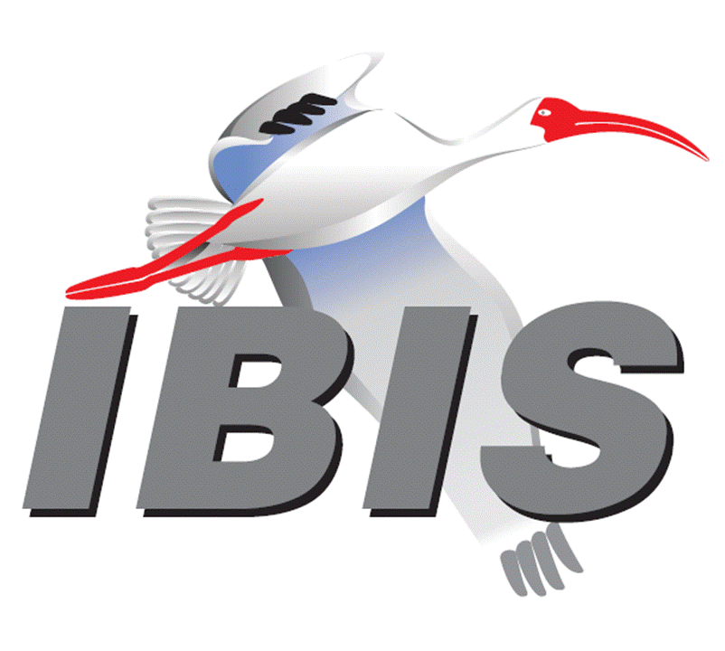
IBIS Hybrid Summit with DesignCon 2024
February 2, 2024
Agenda
All times PST
8:00 AM | SIGN IN AND BREAKFAST BUFFET  Food available at 7:45 AM
8:10 AM | Welcome  Lance Wang (Zuken USA, USA)  (Chair, IBIS Open Forum)
8:15 AM | IBIS Chair’s Report  Lance Wang (Zuken USA, USA)  (Chair, IBIS Open Forum)
8:30 AM | Enabling Cross Connected Differential Tx-Rx System Using IBIS [Series_switch]  Raushan Kumar (STMicroelectronics, India)  Rahul Kumar (STMicroelectronics, India)  Manish Bansal (STMicroelectronics, India)  [Presented by Raushan Kumar]
8:45 AM | More IBIS History  Bob Ross (Teraspeed Labs, USA)
9:05 AM | A Practical Review of IBIS DDR5 Enhancements  Doug Burns (SI-Clarity, USA)  Pegah Alavi (Keysight Technologies, USA)  [Presented by Pegah Alavi]
9:45 AM | OFFICER GIFT and BREAK (20 minutes)
10:05 AM | Using Measured Waveform Data in AMI Simulation for System Design  Hee-Soo Lee (Keysight Technologies, USA)  Fangyi Rao (Keysight Technologies, USA)  Yoonman Choi (SK Hynix, Korea)  [Presented by Yoonman Choi]
10:35 AM | BIRD229: [AMI Test Configuration] – Standardizing Algorithmic Model Testing  Michael Mirmak (Intel, USA)
10:55 PM | Update on BIRD226: PSIJ Sensitivity  Kinger Cai (Intel, USA)  Fern Nee Tan (Intel, Malaysia)  Chi-te Chen (Intel, USA)  Michael Mirmak (Intel, USA)  [Presented by Kinger Cai]
11:20 PM | The Optimization of IBIS-AMI Model Parameters with Machine Learning Algorithms  Jared James (Cadence Design Systems, USA)  Ambrish Varma (Cadence Design Systems, USA)  [Presented by Jared James]
12:00 PM | FREE LUNCH, NETWORKING
1:30 PM | IBIS Quality 3.0 Checklist Spreadsheet  Weston Beal (Siemens EDA, USA)
2:05 PM | Matrix Parameters in Touchstone (Updated)  Bob Ross (Teraspeed Labs, USA)
2:30 PM | Update on BIRD223.1: Add Support for SPIM in IBIS  Kinger Cai (Intel, USA)  Chi-te Chen (Intel, USA)  [Presented by Kinger Cai]
2:45 PM | Addressing the Challenges of PAM-3 USB 4.0 - Design and Analysis  Zhiping Yang (MST EMC Lab and JAY Plus, USA)  Zhen Mu (Cadence Design Systems, USA)  Kyle Lake (Cadence Design Systems, USA)  [Presented by Zhiping Yang]
3:15 PM | OPEN DISCUSSION
3:30 PM | CLOSING REMARKS  - Next IBIS Open Forum Meeting Friday, February 16, 2024
 | END OF MEETING



